CHAPTER 4: SYSTEM ANALYSIS AND DESIGN

4.1 Introduction
This chapter provides a detailed overview of the system analysis and design activities carried out during the development of the CertifyChain platform. System analysis focuses on examining and understanding the system's functional and non-functional requirements. In contrast, system design involves converting those requirements into a clear architectural and component-level plan suitable for implementation. Together, these activities ensure that every part of the system is well-defined, logically organized, and aligned with the research goals outlined in Chapter 1.
The chapter is organized into three main sections. The first section covers systems analysis, including identifying functional and non-functional requirements, use case modeling, and sequence diagrams that show interaction patterns among actors and system components. The second section focuses on system design, divided into software design (architectural design, class modeling, and component breakdown), user interface design, and database design. The third section details component-level design, featuring state diagrams, activity diagrams, and decision tables to describe the system's detailed behavioral logic. A deployment diagram is also included to show the physical distribution of the system across its hosting infrastructure.
The object-oriented requirements modeling approach was chosen for this project because the core components of the CertifyChain system are entities like certificates, students, institutions, users, and verification logs, rather than standalone functions. This method aligns well with the Clean Architecture pattern used in the backend and helps create a clearer connection between the analysis models and the implementation code.

4.2 Systems Analysis
Systems analysis focuses on understanding what the system should do. It involves the organized collection, interpretation, and documentation of requirements that describe the capabilities, constraints, and quality attributes expected of the CertifyChain platform. The analysis in this section is based on the objectives and scope outlined in Chapter 1, the literature reviewed in Chapter 2, and the methodological framework established in Chapter 3.

4.2.1 Functional Requirements
Functional requirements specify the features and capabilities the system must have. Each requirement is given a unique identifier for traceability. The requirements are organized based on the main subsystem they relate to.
Table 4.1: Functional Requirements of the CertifyChain System
ID | Requirement Description | Subsystem | Actor(s)
FR01 | The system shall allow authorised administrators of the institution to create and manage student profiles, including personal details and academic programme enrolment. | Web Application | Institution Admin, Registrar
FR02 | The system shall enable authorised users to issue digital academic certificates by uploading a PDF document, computing its SHA-256 hash, uploading the hash to IPFS, and recording it on the Ethereum blockchain via a smart contract. | Web Application, Blockchain, IPFS | Registrar, Institution Admin
FR03 | The system shall support batch issuance of up to 50 certificates in a single blockchain transaction to reduce gas costs and improve operational efficiency. | Web Application, Blockchain | Registrar, Institution Admin
FR04 | The system shall allow any user to verify the authenticity of a certificate by entering its hash or scanning its QR code, triggering a parallel query against both the blockchain smart contract and the backend API. | Web App, Website, Mobile App | Public Verifier, Employer
FR05 | The system shall generate a unique QR code for each issued certificate that encodes the verification URL containing the certificate hash. | Web Application | System (Automated)
FR06 | The system shall permit authorised users of the authorised institution to revoke a certificate on the blockchain, changing its status from Valid to Revoked irreversibly. | Web Application, Blockchain | Institution Admin, Verification Officer
FR07 | The system shall integrate an AI-based fraud detection module that analyses uploaded certificate images for signs of visual tampering, splicing, and deepfake artefacts, returning a confidence score between 0 and 100 percent. | Backend API, AI Service | System (Automated)
FR08 | The system shall provide a role-based access control mechanism with six distinct roles and over thirty granular permissions governing access to all system features. | Backend API, Web Application | Super Admin, Institution Admin
FR09 | The system shall support multi-tenancy, ensuring that each institution operates within an isolated data partition where its students, certificates, and users are invisible to other institutions. | Backend API, Database | System (Automated)
FR10 | The system shall authenticate users using JWT-based tokens with automatic refresh and shall support Google OAuth sign-in on the public website and in the mobile application. | All Platforms | All Users
FR11 | The system shall maintain an immutable audit trail of all verification attempts, recording the certificate hash, verification outcome, verifier type, IP address, and timestamp. | Backend API, Database | Verification Officer, Auditor
FR12 | The system shall provide a dashboard displaying real-time analytics, including certificate status counts, issuance trends, verification source distribution, and top programmes. | Web Application, Website | Institution Admin, Auditor
FR13 | The system shall allow the Super Admin to authorise, deauthorise, and reauthorise institutions on the blockchain smart contract, as well as to update institutional wallet addresses. | Web Application, Blockchain | Super Admin
FR14 | The system shall allow students to view their verified certificates, receive notifications upon issuance, and share QR codes with employers through the mobile application. | Mobile Application | Student
FR15 | The system shall upload certificate PDF files to the InterPlanetary File System (IPFS) via Pinata, returning a content-addressed identifier (CID) that is stored both on-chain and in the backend database. | Backend API, IPFS, Blockchain | System (Automated)

4.2.2 Non-Functional Requirements
Non-functional requirements define the quality attributes and constraints that control the system's overall behavior. These requirements complement the functional ones by specifying how the system should operate rather than what it should do.
Table 4.2: Non-Functional Requirements
ID | Requirement Description | Category
NFR01 | The system shall respond to verification queries within five seconds under normal network conditions. | Performance
NFR02 | The blockchain smart contract shall ensure that all certificate records are immutable and tamper-proof once written. | Security
NFR03 | The system shall encrypt all data in transit using HTTPS/TLS and shall store sensitive credentials using industry-standard hashing algorithms. | Security
NFR04 | The backend API shall be capable of handling at least 100 concurrent verification requests without degrading response time. | Scalability
NFR05 | The user interface shall be responsive and accessible on desktop browsers (Chrome, Firefox, Edge) and mobile devices (Android 10+, iOS 14+). | Usability
NFR06 | The system shall maintain 99.5 per cent uptime for the backend API and public verification endpoints. | Availability
NFR07 | The system shall comply with data privacy principles by storing only cryptographic hashes on the blockchain and never persisting raw certificate files in the relational database. | Privacy
NFR08 | The AI fraud detection module shall achieve a minimum accuracy of 95 percent on the test dataset. | Accuracy
NFR09 | The system shall be developed using open-source frameworks and tools to minimise licensing costs and promote long-term maintainability. | Maintainability
NFR10 | The system shall support horizontal scaling of the backend API through containerisation with Docker. | Scalability

4.2.3 Use Case Modelling
Use case modeling offers a high-level overview of the system from the perspective of its actors and the functions they may trigger. The CertifyChain system involves multiple human actors and external system actors, each engaging with the platform through specific sets of use cases.

4.2.3.1 Actors
Table 4.3: System Actors and Descriptions
Actor | Type | Description
Super Admin | Human | The platform-level administrator who manages all institutions, authorises or deauthorises institutions on the blockchain, and oversees system-wide settings.
Institution Admin | Human | The institutional-level administrator who manages users, configures blockchain settings, and oversees the certificate lifecycle within a single institution.
Registrar | Human | The academic official responsible for issuing, viewing, and managing certificates and student records within an institution.
Faculty Admin | Human | An academic staff member who views certificates and manages academic programmes within their faculty.
Verification Officer | Human | An institutional official authorised to verify and revoke certificates and to view verification history.
Auditor | Human | A read-only user who accesses audit logs, verification history, reports, and dashboard analytics.
Employer / Public Verifier | Human | Any external party (employer, government agency, or other institution) that verifies the authenticity of a certificate.
Student | Human | A graduate or current student who views their certificates, receives issuance notifications, and shares QR codes via the mobile application.
Ethereum Blockchain | External System | The Ethereum Sepolia testnet stores immutable hashes of certificates and executes smart contract logic for issuance, verification, and revocation.
IPFS (Pinata) | External System | The InterPlanetary File System, accessed through Pinata Cloud, provides decentralised, content-addressed storage for certificate PDF files.
AI Fraud Detection Service | External System | The machine learning service that analyses certificate images for visual tampering and returns a fraud confidence score.

4.2.3.2 Use Case Diagrams
The use case diagrams for the CertifyChain system are shown in three views to keep things clear, considering the number of actors and use cases involved. The first diagram (Figure 4.1) displays the administrative actors and their related use cases, including the generalization (inheritance) relationships among roles. The second diagram (Figure 4.2) presents the external actors (Employer, Student) and the external system actors (Ethereum Blockchain, IPFS, AI Fraud Detection Service) along with the verification and student-facing use cases. The third diagram (Figure 4.3) concentrates on the certificate lifecycle, illustrating the include-and-extend relationships among the issuance, verification, and revocation use cases and their sub-processes.
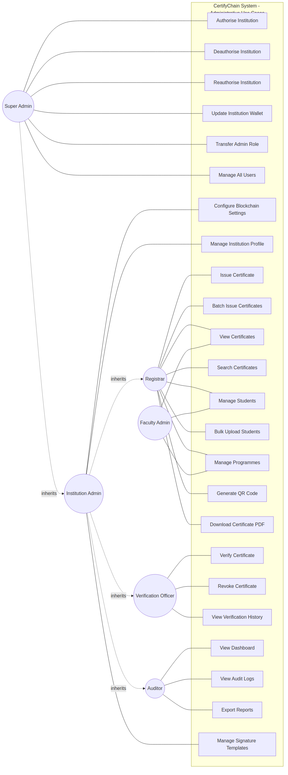
Figure 4.1: Use Case Diagram for Administrative Actors
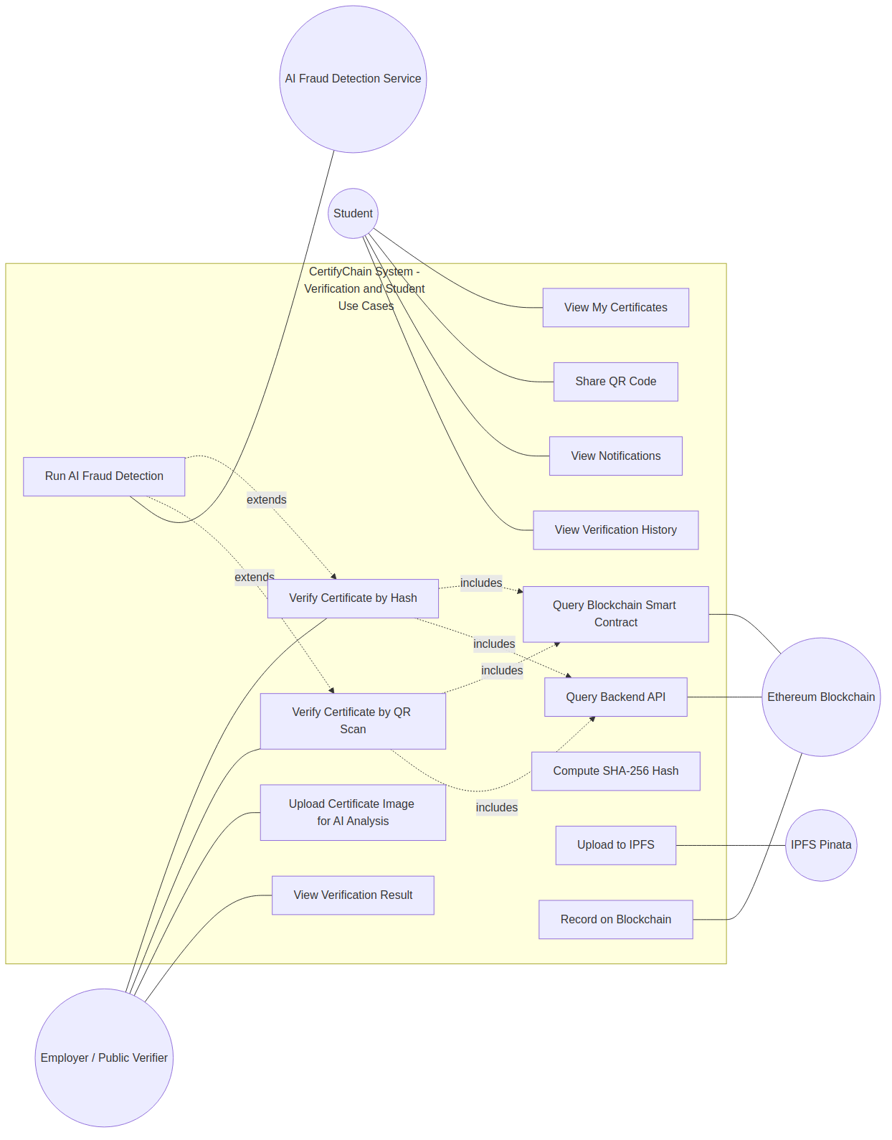

Figure 4.2: Use Case Diagram for Verification and External Actors

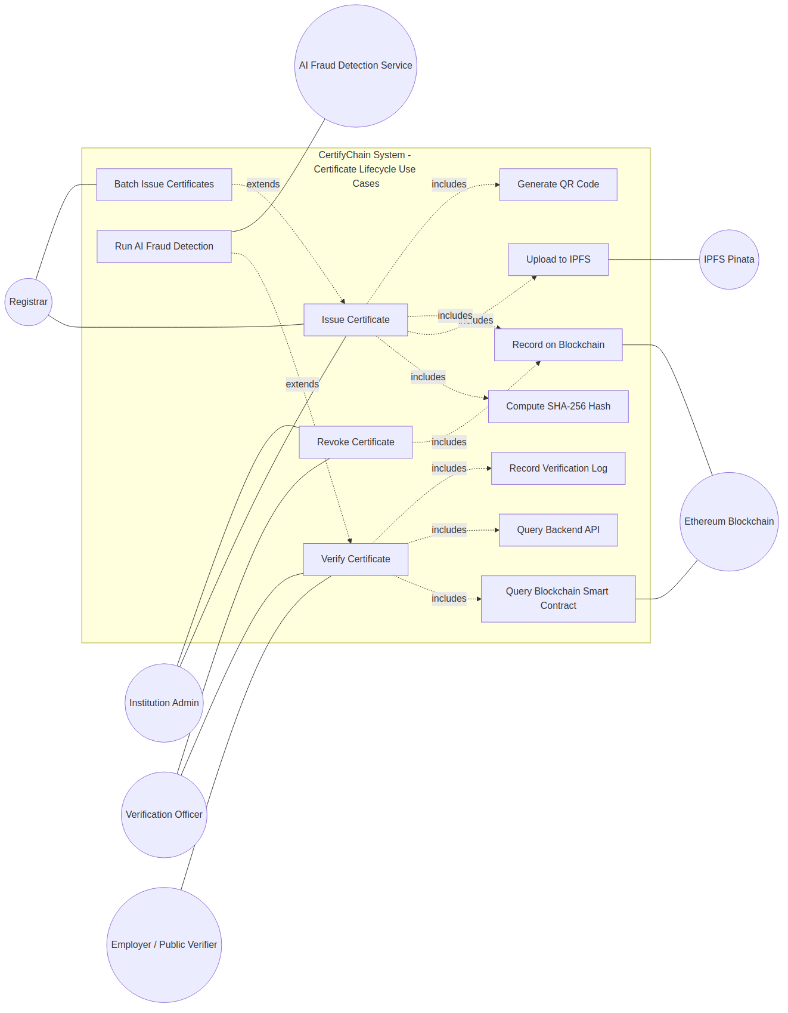
Figure 4.3: Use Case Diagram for Certificate Lifecycle with Include and Extend Relationships

Generalisation (Inheritance) Relationships among Actors: The Institution Admin actor inherits all use cases available to the Registrar, Faculty Admin, Verification Officer, and Auditor, reflecting its extensive administrative privileges. Similarly, the Super Admin inherits all functions of the Institution Admin and adds platform-level management features.
Include Relationships: The use case "Issue Certificate" includes the use cases "Compute SHA-256 Hash," "Upload to IPFS," and "Record on Blockchain," as these sub-processes are always part of the issuance workflow. Similarly, the use case "Verify Certificate" includes "Query Blockchain Smart Contract" and "Query Backend API," since both verification paths are invoked in parallel during every verification request.
Extend Relationships: The use case "Run AI Fraud Detection" extends "Verify Certificate" at the extension point where the verifier uploads a certificate image instead of entering a hash. This shows that AI analysis is an optional addition to the standard verification process. Similarly, "Batch Issue Certificates" extends "Issue Certificate" when the registrar opts to process multiple certificates in one blockchain transaction.

Table 4.4: Summary of Use Cases by Actor
Actor | Use Cases
Super Admin | Authorise Institution, Deauthorise Institution, Reauthorise Institution, Update Institution Wallet, Transfer Admin Role, Manage All Users, View All Institutions, View Platform Dashboard
Institution Admin | All Registrar use cases, plus: Manage Users, Configure Blockchain Settings, Manage Institution Profile, View Institution Dashboard, and Manage Signature Templates.
Registrar | Issue Certificate, Batch Issue Certificates, View Certificates, Search Certificates, Manage Students, Bulk Upload Students, Manage Programmes, Generate QR Code, Download Certificate PDF
Faculty Admin | View Certificates, View Students, Manage Programmes
Verification Officer | Verify Certificate, Revoke Certificate, View Verification History
Auditor | View Dashboard, View Audit Logs, View Verification History, Export Reports
Employer / Public Verifier | Verify Certificate (by hash), Verify Certificate (by QR scan), Upload Certificate Image for AI Analysis, View Verification Result
Student | View My Certificates, Share QR Code, View Notifications, View Verification History
Ethereum Blockchain | Store Certificate Hash, Verify Certificate Hash, Update Certificate Status, and Manage Institution Authorisation
IPFS (Pinata) | Store Certificate PDF, Retrieve Certificate PDF by CID
AI Fraud Detection Service | Analyse Certificate Image, Return Fraud Confidence Score

4.2.4 Detailed Use Case Descriptions
This section provides detailed use-case descriptions of the most critical processes in the CertifyChain system. Each use case follows a standardised template.
Use Case 1: Issue Certificate
Use Case Name | Issue Certificate
Actor(s) | Registrar (initiator), Institution Admin; External Systems: Ethereum Blockchain, IPFS (Pinata)
Purpose | To enable an authorised institutional user to create, hash, store, and permanently register an academic certificate on the blockchain, ensuring its immutability and verifiability.
Overview | This use case begins when the Registrar navigates to the certificate issuance wizard in the admin web application. The process involves four steps: entering student information, entering certificate details, uploading the certificate PDF (which triggers SHA-256 hashing and IPFS upload), and submitting the transaction to the Ethereum smart contract via MetaMask. On completion, the certificate is recorded both on-chain and in the backend database, and a QR code is generated.
Cross References | FR02, FR05, FR15
Pre-conditions | (1) The Registrar is authenticated and possesses the CreateCertificates permission. (2) The student profile exists in the system. (3) The institution's wallet is authorised on the smart contract. (4) MetaMask is installed and connected to the Sepolia network with sufficient ETH for gas.
Post-conditions | (1) The certificate hash is recorded on the Ethereum blockchain with a status of Valid. (2) The certificate PDF is stored on IPFS with a unique CID. (3) The certificate record is persisted in the backend database. (4) A QR code containing the verification URL is generated.
Type | Primary, Essential
Priority | High
Frequency of Use | Multiple times per day during graduation periods; periodically during the academic year.

Typical Course of Events for Use Case 1: Issue Certificate
# | Actor Action | System Response
1 | The Registrar navigates to the certificate issuance page and selects "New Certificate." | The system displays the four-step issuance wizard.
2 | The Registrar searches for or selects the student. | The system populates the student fields from the selected record.
3 | The Registrar proceeds to Step 2 and enters certificate details. | The system validates the data against the academic structure.
4 | The Registrar proceeds to Step 3 and uploads the certificate PDF. | The system computes the SHA-256 hash client-side, uploads the PDF to IPFS via Pinata, and retrieves the CID.
5 | The Registrar clicks "Connect Wallet." | The system invokes MetaMask and verifies that the wallet matches the authorised institution's wallet.
6 | The Registrar reviews the estimated gas and clicks "Issue on Blockchain." | The system calls issueCertificate on the smart contract. MetaMask displays the confirmation dialogue.
7 | The Registrar approves the transaction in MetaMask. | The smart contract validates the caller, checks for duplicates, records the certificate, and emits the CertificateIssued event.
8 |  | The system persists the record in the backend database via the POST /api/certificates endpoint.
9 |  | The system generates a QR code and displays success with the Etherscan transaction link.
Alternatives: Step 4: If the IPFS upload fails, the system allows a retry. Step 5: If the wallet is unauthorised, the system prevents the transaction from being processed. Step 7: If the transaction fails, the system displays the error.

Use Case 2: Verify Certificate
Use Case Name | Verify Certificate
Actor(s) | Employer / Public Verifier (initiator); External Systems: Ethereum Blockchain, AI Fraud Detection Service
Purpose | To enable any user to verify the authenticity and current status of an academic certificate by querying both the blockchain smart contract and the backend API simultaneously.
Overview | This use case begins when a verifier enters a 64-character hexadecimal certificate hash or scans a certificate QR code. Two parallel verification requests execute simultaneously: a read-only call to the blockchain smart contract and a GET request to the backend API. The results are merged and displayed. On completion, a verification log entry is recorded.
Cross References | FR04, FR07, FR11
Pre-conditions | (1) The verifier has access to the certificate hash. (2) An internet connection is available. (3) Authentication is not required for basic verification.
Post-conditions | (1) The verification result (Verified, Not Found, or Revoked) is displayed with full metadata if found. (2) A verification log entry is persisted.
Type | Primary, Essential
Priority | High
Frequency of Use | High. Expected to be used hundreds of times daily in production.

Typical Course of Events for Use Case 2: Verify Certificate
# | Actor Action | System Response
1 | The verifier navigates to the verification page. | The system displays the verification interface.
2 | The verifier enters the hash or scans the QR code. | If QR, the system extracts the hash from the encoded URL.
3 | The verifier clicks "Verify." | Two parallel requests: (a) getCertificateDetails on the smart contract (zero gas), (b) GET /api/certificates/by-hash/{hash}.
4 |  | The blockchain returns the on-chain record or indicates not found.
5 |  | The backend API returns enriched metadata or 404.
6 |  | The system merges results and determines the final status.
7 |  | The system displays the result with full details if verified.
8 |  | The system records a verification log via the POST /api/verification-logs endpoint.
Alternatives: Step 2: If QR is damaged, the verifier enters the hash manually. Step 3: If the verifier uploads an image, the AI Fraud Detection Service is invoked. Step 4: If blockchain is unreachable, the system falls back to backend results.

Use Case 3: Revoke Certificate
Use Case Name | Revoke Certificate
Actor(s) | Institution Admin, Verification Officer (initiator); External System: Ethereum Blockchain
Purpose | To permanently revoke a previously issued certificate on the blockchain, changing its status from Valid to Revoked.
Overview | This use case begins when the user navigates to the revocation page and connects their MetaMask wallet to the issuing institution. The user enters the certificate hash, confirms revocation after reviewing the irreversibility warning, and the status is updated on-chain and in the backend.
Cross References | FR06
Pre-conditions | (1) The user has RevokeCertificates permission. (2) The certificate exists with a valid status. (3) The wallet matches the issuing institution.
Post-conditions | (1) Status changed to Revoked (2) on-chain. (2) Backend record updated. (3) All subsequent verifications return Revoked.
Type | Primary, Essential
Priority | High
Frequency of Use | Low. Revocation is an exceptional event.

Use Case 4: Run AI Fraud Detection
Use Case Name | Run AI Fraud Detection
Actor(s) | Employer / Public Verifier (initiator); External System: AI Fraud Detection Service
Purpose | To analyse an uploaded certificate image using artificial intelligence to detect visual tampering, splicing, overlay manipulation, and deepfake artefacts.
Overview | This use case begins when a verifier uploads a certificate image during verification. The system forwards the image to the AI service, which analyses it using ResNet50v2 combined with XGBoost. A fraud confidence score (0 to 100 percent) is returned and appended to the verification results.
Cross References | FR07
Pre-conditions | (1) The verifier has a certificate image (JPEG or PNG). (2) The AI service is operational.
Post-conditions | (1) A fraud confidence score is associated with the verification record. (2) The score is displayed to the verifier.
Type | Secondary, Essential
Priority | Medium
Frequency of Use | Moderate. Invoked when verifiers upload a certificate image.

Use Case 5: Authorise Institution on Blockchain
Use Case Name | Authorised Institution on Blockchain
Actor(s) | Super Admin (initiator); External System: Ethereum Blockchain
Purpose | To register and activate a new academic institution on the smart contract, enabling it to issue and manage certificates.
Overview | This use case begins when the Super Admin provides the institution ID, wallet address, and display name. On completion, the institution is registered on the smart contract.
Cross References | FR13
Pre-conditions | (1) The Super Admin holds the admin role on the smart contract. (2) The institution ID is unique.
Post-conditions | (1) The institution is registered on the smart contract. (2) Its wallet is authorised to issue and revoke certificates.
Type | Primary, Essential
Priority | High
Frequency of Use | Low. Executed once per new institution.

4.2.5 Sequence Diagrams
Sequence diagrams illustrate the time-ordered flow of messages between objects for each primary use case. The following diagrams present the interaction sequences for the three most critical processes.
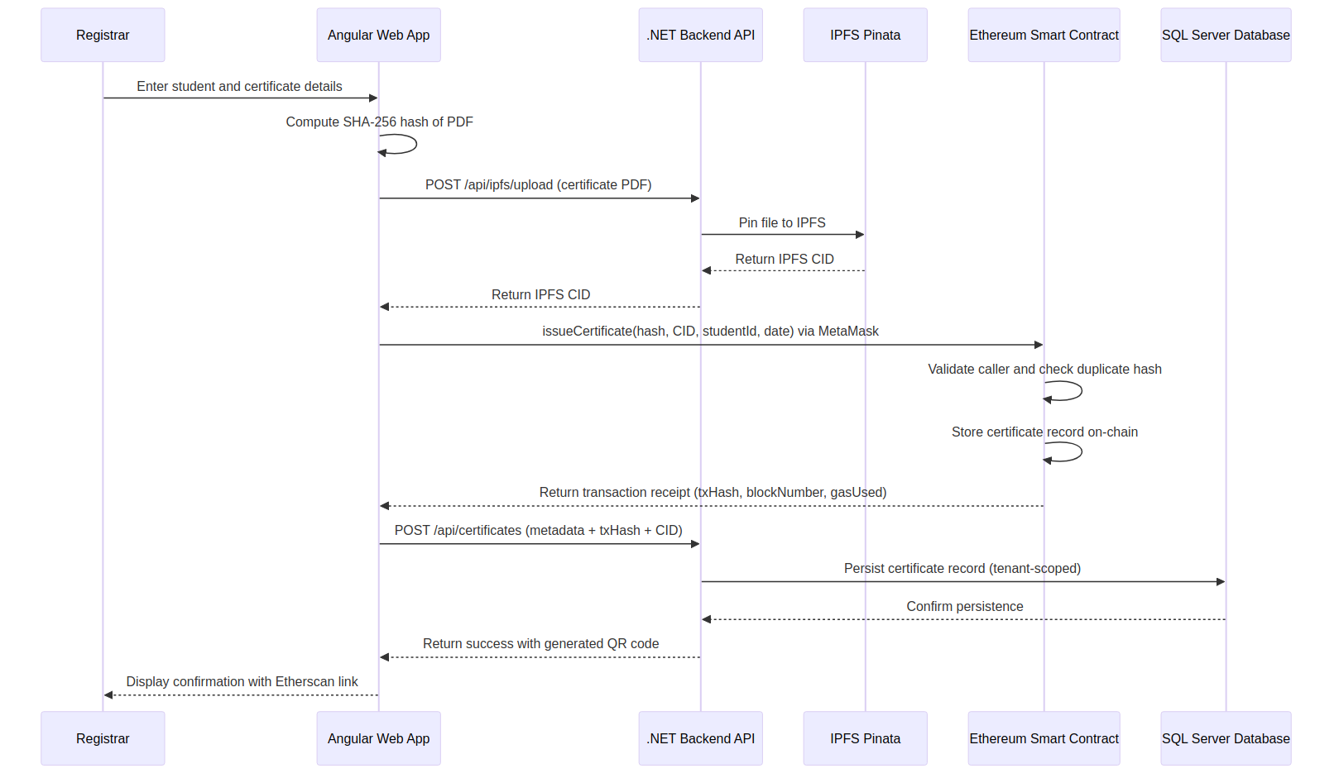
Figure 4.4: Sequence Diagram for Certificate Issuance

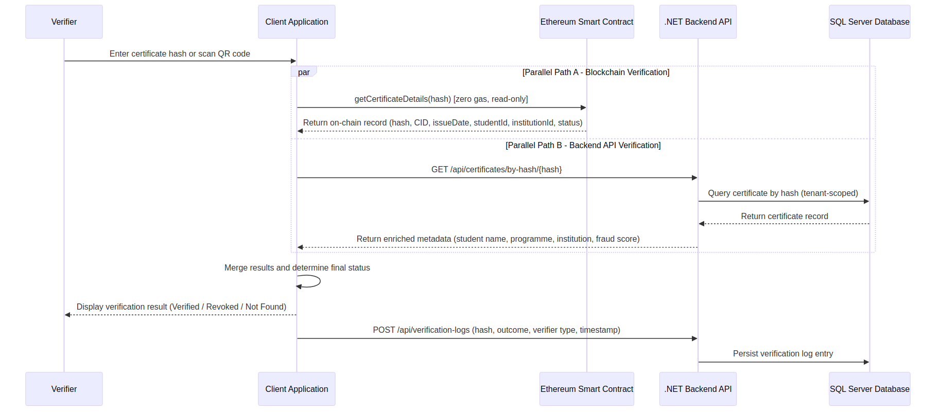
Figure 4.5: Sequence Diagram for Certificate Verification (Parallel Paths)
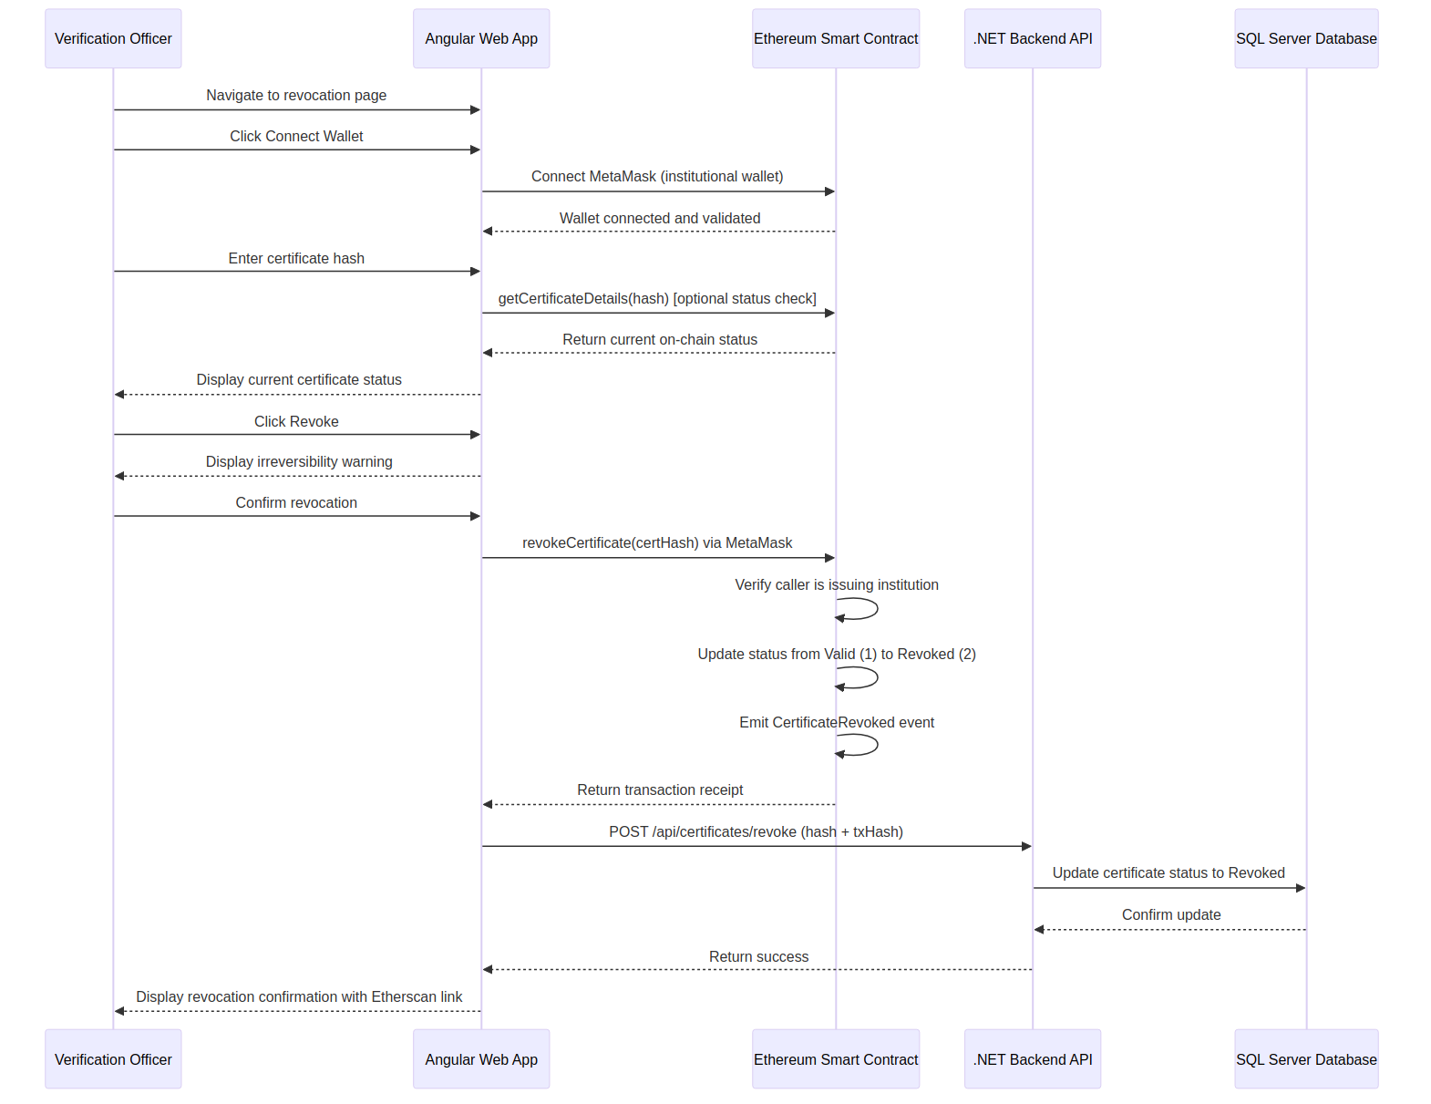

Figure 4.6: Sequence Diagram for Certificate Revocation

4.3 System Design
System design converts requirements and analysis models into a detailed blueprint that guides the implementation phase. This section is divided into three subsections: software design, user interface design, and database design.

4.3.1 Software Design

4.3.1.1 Architectural Design
The CertifyChain system adopts a mix of Client-Server and Layered architectural patterns. The client tier includes three separate front-end applications: an Angular admin web app, a Next.js public website, and a Flutter mobile app, all communicating with a centralized .NET 10 backend API via HTTPS using JWT-based authentication. The backend follows Clean Architecture principles, divided into three layers: the API layer, the Core layer, and the Data layer. It connects with three external systems: SQL Server for relational storage, the Ethereum Sepolia blockchain for immutable storage of certificate hashes, and IPFS via Pinata for decentralized document storage.
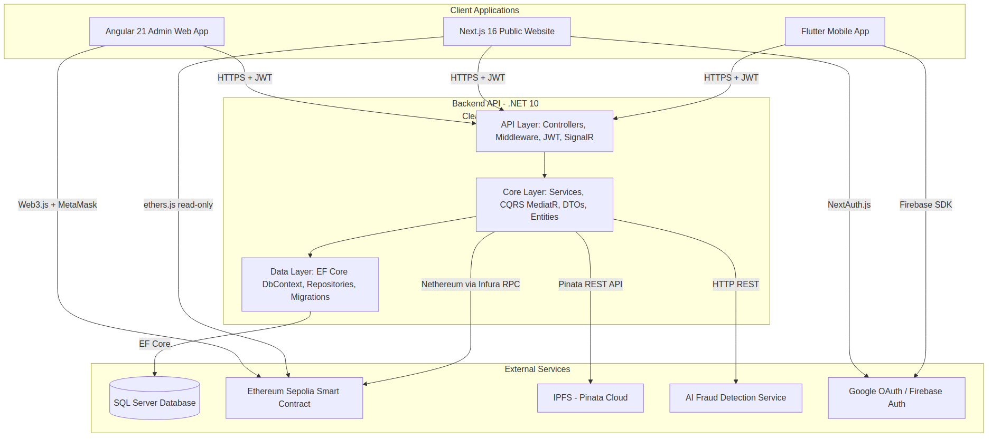
Figure 4.7: System Architecture Diagram

4.3.1.2 Class Diagram
The class diagram illustrates the static structure of the CertifyChain system by showing its main domain entities, their attributes, methods, and relationships. The diagram uses composition relationships between Institution and its parts, association relationships connecting Certificate to Student and Programme, and interface realization with the ITenantEntity interface for multi-tenancy support.
Table 4.5: Principal Domain Classes
Class Name | Key Attributes | Key Methods | Relationships
Certificate | Id, CertificateNumber, CertificateHash, IpfsCid, BlockchainTxHash, BlockNumber, GasUsed, Status, QualificationType, AwardClassification, GraduationDate, FraudScore, TenantId | Issue(), Revoke(), GenerateQRCode(), ComputeHash() | Belongs to Student (M:1), Belongs to Programme (M:1), Has many VerificationLogs (1:M)
Student | Id, StudentNumber, FirstName, LastName, DateOfBirth, Email, Phone, TenantId | Enrol(), UpdateProfile() | Has many Certificates (1:M), Belongs to Programme (M:1)
Institution | Id, Name, WalletAddress, IsAuthorised, LogoUrl, ContactEmail, TenantId | Authorise(), Deauthorise(), UpdateWallet() | Has many Users (1:M), Has many Students (1:M), Has many Faculties (1:M)
User | Id, Email, PasswordHash, FirstName, LastName, Role, Permissions, TenantId | Authenticate(), AssignRole(), ResetPassword() | Belongs to Institution via Tenant (M:1), Has many VerificationLogs (1:M)
Programme | Id, Name, Code, DurationType, DurationValue, TenantId | Create(), Update(), Delete() | Belongs to Faculty (M:1), Has many Students (1:M), Has many Certificates (1:M)
Faculty | Id, Name, Code, TenantId | Create(), Update(), Delete() | Belongs to Institution via Tenant (M:1), Has many Programmes (1:M)
VerificationLog | Id, CertificateHash, IsSuccessful, VerifierType, IpAddress, Timestamp, TenantId | Record() | Belongs to Certificate (M:1), Optionally belongs to User (M:1)
Tenant | Id, Name, Slug, IsActive | Activate(), Deactivate() | Has many of all tenant-scoped entities (1:M)

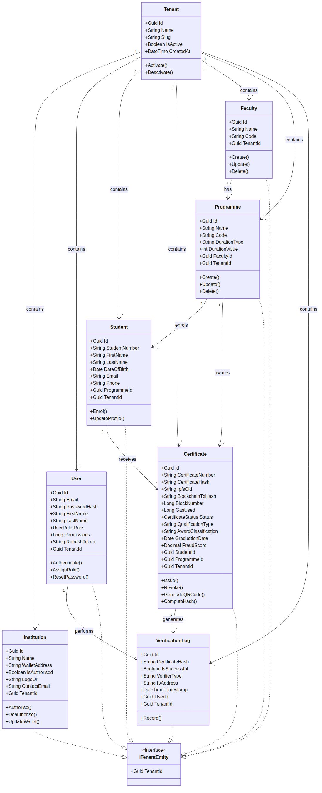
Figure 4.8: Class Diagram of the CertifyChain System
4.3.1.3 Smart Contract Data Model
Besides the relational database model, the CertifyChain system keeps a separate data model on the Ethereum blockchain within the CertificateVerification smart contract. This on-chain model is intentionally minimal to cut gas costs.
Table 4.6: On-Chain Certificate Record Structure
Field | Solidity Type | Description
certHash | bytes32 | The keccak256 hash of the certificate document.
ipfsCID | bytes32 | The IPFS content identifier of the full certificate PDF.
issueDate | uint64 | The Unix timestamp of the issuance date.
studentId | bytes16 | The alphanumeric student identifier (maximum 15 characters).
institutionId | uint16 | The numeric identifier of the issuing institution.
status | uint8 | Certificate status: 0 (Invalid), 1 (Valid), 2 (Revoked).
exists | bool | Guard flag indicating whether the record exists.

4.3.2 User Interface Design
The principles of clarity, consistency, and accessibility guided the user interface design of the CertifyChain system. Three distinct interfaces were designed to serve the primary user groups.
Admin Web Application (Angular 21): The admin web application features a sidebar navigation layout with a fixed top bar. It is built using PrimeNG with Tailwind CSS and supports both light and dark themes. Key screens include the Dashboard with Chart.js analytics, a four-step Certificate Issuance Wizard with MetaMask integration, a paginated Certificate List, a public Verification Page, and a User Management interface with role assignment.
Public Website (Next.js 16): The public website features a professional landing page, a prominent verification input field, and QR code scanning support. Verification results display clear status indicators with full metadata and blockchain proof. Google OAuth via NextAuth.js provides access to a personal verification dashboard.
Mobile Application (Flutter): The app focuses on QR code scanning. The home screen has four tabs: Dashboard, Scan, History, and Profile. It supports system-aware dark mode and Google Sign-In via Firebase Authentication.

4.3.3 Database Design
The CertifyChain system uses Microsoft SQL Server through Entity Framework Core 10 with a Code-First migration approach. The database supports multi-tenancy with global query filters on the TenantId column.

4.3.3.1 Entity-Relationship Diagram
The entity-relationship diagram shows the main entities and their cardinality constraints. All entities except Tenant include a TenantId foreign key for multi-tenancy partitioning.
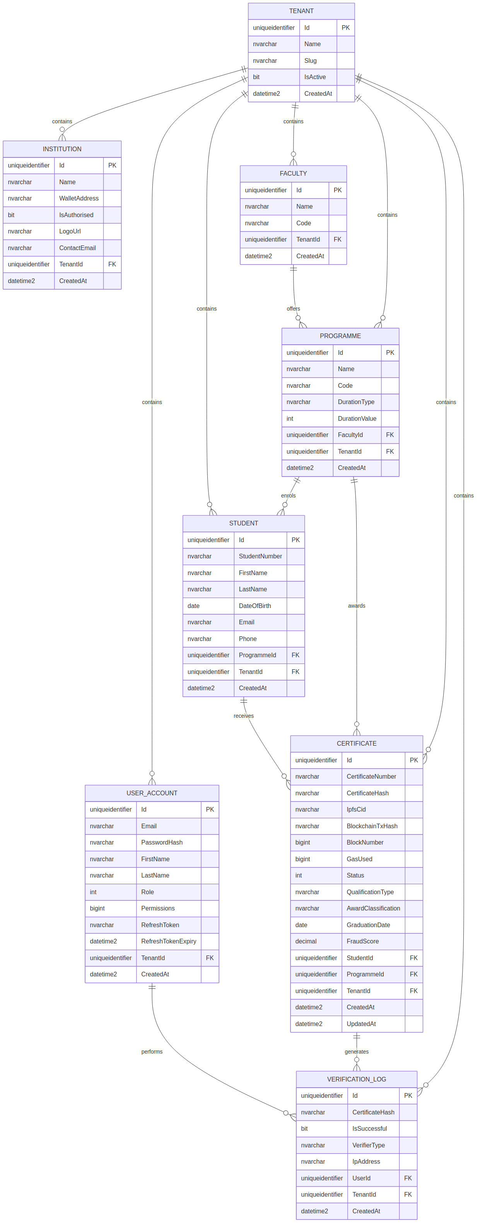
Figure 4.9: Entity-Relationship Diagram of the CertifyChain Database
4.3.3.2 Table Structures
Table 4.7: Certificates Table Structure
Column Name | Data Type | Constraints | Description
Id | UNIQUEIDENTIFIER | PK, NOT NULL | Unique identifier.
CertificateNumber | NVARCHAR(50) | UNIQUE, NOT NULL | Human-readable certificate number.
CertificateHash | NVARCHAR(66) | UNIQUE, NOT NULL, INDEXED | SHA-256 hash of the certificate document.
IpfsCid | NVARCHAR(100) | NOT NULL | IPFS content identifier.
BlockchainTxHash | NVARCHAR(66) | NULL | Ethereum transaction hash.
BlockNumber | BIGINT | NULL | Block number of confirmation.
GasUsed | BIGINT | NULL | Gas consumed by the transaction.
Status | INT | NOT NULL, DEFAULT 0 | 0 = Pending, 1 = Verified, 2 = Revoked.
QualificationType | NVARCHAR(100) | NOT NULL | Type of qualification.
AwardClassification | NVARCHAR(50) | NULL | Award class.
GraduationDate | DATE | NOT NULL | Graduation date.
FraudScore | DECIMAL(5,2) | NULL | AI fraud detection score (0.00 to 100.00).
StudentId | UNIQUEIDENTIFIER | FK, NOT NULL | FK to Students table.
ProgrammeId | UNIQUEIDENTIFIER | FK, NOT NULL | FK to Programmes table.
TenantId | UNIQUEIDENTIFIER | FK, NOT NULL, INDEXED | FK to Tenants table.
CreatedAt | DATETIME2 | NOT NULL | Record creation timestamp.
UpdatedAt | DATETIME2 | NULL | Last modification timestamp.

Table 4.8: Students Table Structure
Column Name | Data Type | Constraints | Description
Id | UNIQUEIDENTIFIER | PK, NOT NULL | Unique identifier.
StudentNumber | NVARCHAR(20) | UNIQUE, NOT NULL | Institutional student ID.
FirstName | NVARCHAR(100) | NOT NULL | First name.
LastName | NVARCHAR(100) | NOT NULL | Surname.
DateOfBirth | DATE | NOT NULL | Date of birth.
Email | NVARCHAR(256) | NULL | Email address.
Phone | NVARCHAR(20) | NULL | Phone number.
ProgrammeId | UNIQUEIDENTIFIER | FK, NOT NULL | FK to Programmes table.
TenantId | UNIQUEIDENTIFIER | FK, NOT NULL, INDEXED | FK to Tenants table.
CreatedAt | DATETIME2 | NOT NULL | Record creation timestamp.

Table 4.9: Users Table Structure
Column Name | Data Type | Constraints | Description
Id | UNIQUEIDENTIFIER | PK, NOT NULL | Unique identifier.
Email | NVARCHAR(256) | UNIQUE, NOT NULL | Email for authentication.
PasswordHash | NVARCHAR(500) | NOT NULL | Bcrypt hashed password.
FirstName | NVARCHAR(100) | NOT NULL | First name.
LastName | NVARCHAR(100) | NOT NULL | Surname.
Role | INT | NOT NULL | User role enum.
Permissions | BIGINT | NOT NULL | Bitwise permission flags.
RefreshToken | NVARCHAR(500) | NULL | JWT refresh token.
RefreshTokenExpiry | DATETIME2 | NULL | Refresh token expiry.
TenantId | UNIQUEIDENTIFIER | FK, NOT NULL, INDEXED | FK to Tenants table.
CreatedAt | DATETIME2 | NOT NULL | Record creation timestamp.

Table 4.10: VerificationLogs Table Structure
Column Name | Data Type | Constraints | Description
Id | UNIQUEIDENTIFIER | PK, NOT NULL | Unique identifier.
CertificateHash | NVARCHAR(66) | NOT NULL, INDEXED | Hash of verified certificate.
IsSuccessful | BIT | NOT NULL | Whether verification returned positive.
VerifierType | NVARCHAR(50) | NOT NULL | Type of verifier.
IpAddress | NVARCHAR(45) | NULL | Verifier's IP address.
UserId | UNIQUEIDENTIFIER | FK, NULL | FK to Users (null for anonymous).
TenantId | UNIQUEIDENTIFIER | FK, NULL | FK to Tenants (null for public).
CreatedAt | DATETIME2 | NOT NULL | Verification timestamp.

4.4 Component Level Design
Component-level design elaborates on the architectural and class-level models by specifying the detailed behavioural logic of individual system components.

4.4.1 State Diagram: Certificate Lifecycle
The certificate entity goes through a clearly defined set of states during its lifecycle. The diagram below illustrates these state transitions and the events that cause them.
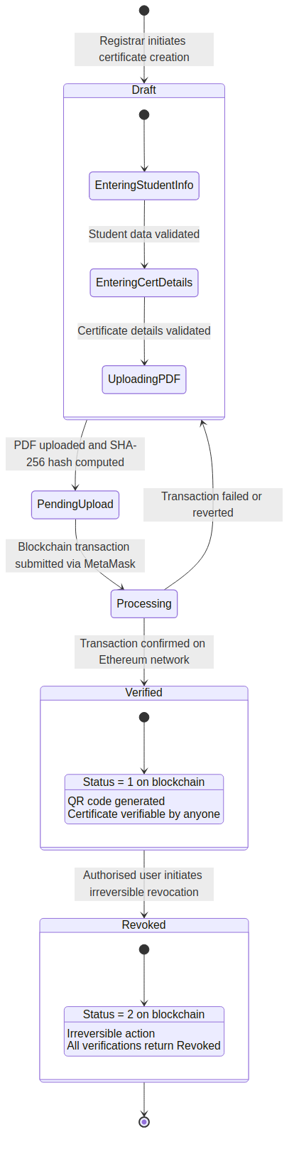
Figure 4.10: State Diagram for the Certificate Lifecycle
Table 4.11: Certificate Lifecycle States and Transitions
Current State | Event / Trigger | Condition | Action | Next State
(Initial) | Registrar initiates creation | Student profile exists | Create pending record | Draft
Draft | PDF uploaded and hashed | SHA-256 computed; IPFS upload successful | Store CID; prepare blockchain parameters | Pending Upload
Pending Upload | Transaction submitted | MetaMask connected; wallet authorised | Smart contract records certificate on-chain | Processing
Processing | Transaction confirmed | Receipt received; block confirmed | Backend persists tx hash and gas; QR generated | Verified (Valid)
Verified (Valid) | Revocation initiated | User has permission; wallet matches issuer | Status changed from 1 to 2 on-chain | Revoked
Processing | Transaction fails | Rejected or reverted | Display error; return for retry | Draft
Revoked | (Terminal) | Irreversible | No further transitions possible | (Final)

4.4.2 Activity Diagrams

4.4.2.1 Activity Diagram: Certificate Issuance
The certificate issuance activity diagram shows the full process from wizard start to confirmation, including parallel execution of SHA-256 hashing and IPFS upload, as well as decision points for validation checks.
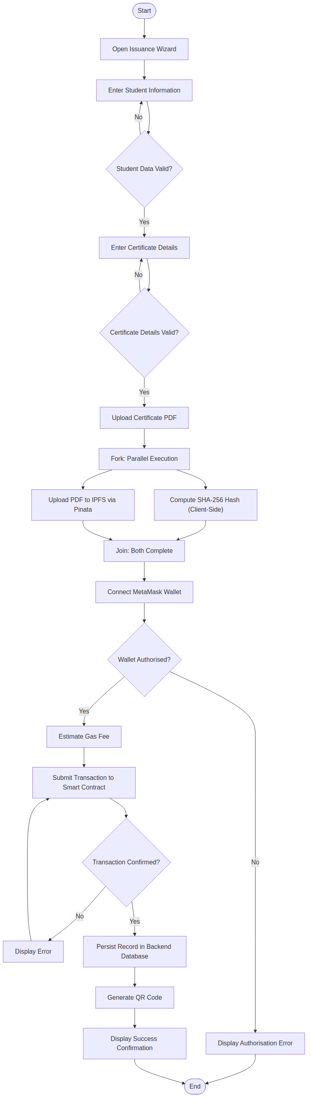
Figure 4.11: Activity Diagram for Certificate Issuance

4.4.2.2 Activity Diagram: Certificate Verification
The certificate verification activity diagram displays the parallel verification architecture, featuring two concurrent paths that query the blockchain and backend API before combining their results.
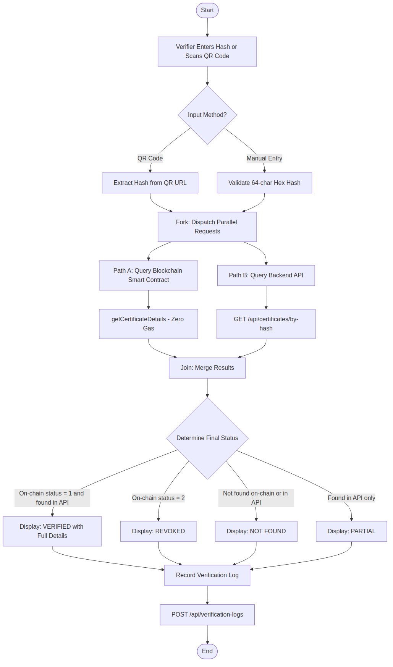
Figure 4.12: Activity Diagram for Certificate Verification

4.4.3 Decision Tables

4.4.3.1 Verification Outcome Decision Table
Table 4.12: Verification Outcome Decision Table
 | Rule 1 | Rule 2 | Rule 3 | Rule 4 | Rule 5
Conditions
Found on blockchain | True | True | True | False | False
On-chain status = Valid (1) | True | False | False | N/A | N/A
On-chain status = Revoked (2) | False | True | False | N/A | N/A
Found in backend API | True | True | False | True | False
Actions
Display: VERIFIED | X
Display: REVOKED |  | X
Display: NOT FOUND |  |  | X |  | X
Display: PARTIAL (backend only) |  |  |  | X
Show full certificate details | X | X |  | X
Record verification log | X | X | X | X | X
Show blockchain proof link | X | X | X

4.4.3.2 Role-Based Access Control Decision Table
Table 4.13: RBAC Permission Matrix (Selected Permissions)
Permission | Super Admin | Inst. Admin | Registrar | Faculty Admin | Verif. Officer | Auditor
Create Certificates | X | X | X
View Certificates | X | X | X | X | X | X
Revoke Certificates | X | X |  |  | X
Batch Upload Certificates | X | X | X
View Students | X | X | X | X
Manage Students | X | X | X
Manage Programmes | X | X |  | X
Create Users | X | X
View Users | X | X |  |  |  | X
Verify Certificate | X | X | X | X | X | X
View Verification History | X | X |  |  | X | X
Fraud Detection | X | X | X |  | X
View Dashboard | X | X | X | X | X | X
View Audit Logs | X | X |  |  |  | X
Export Reports | X | X |  |  |  | X
Institution Settings | X | X
Blockchain Settings | X | X
Manage Signatures | X | X

4.5 Deployment Diagram
The deployment diagram outlines the physical infrastructure where the CertifyChain system components are deployed. The system extends across various hosting environments and external service providers.
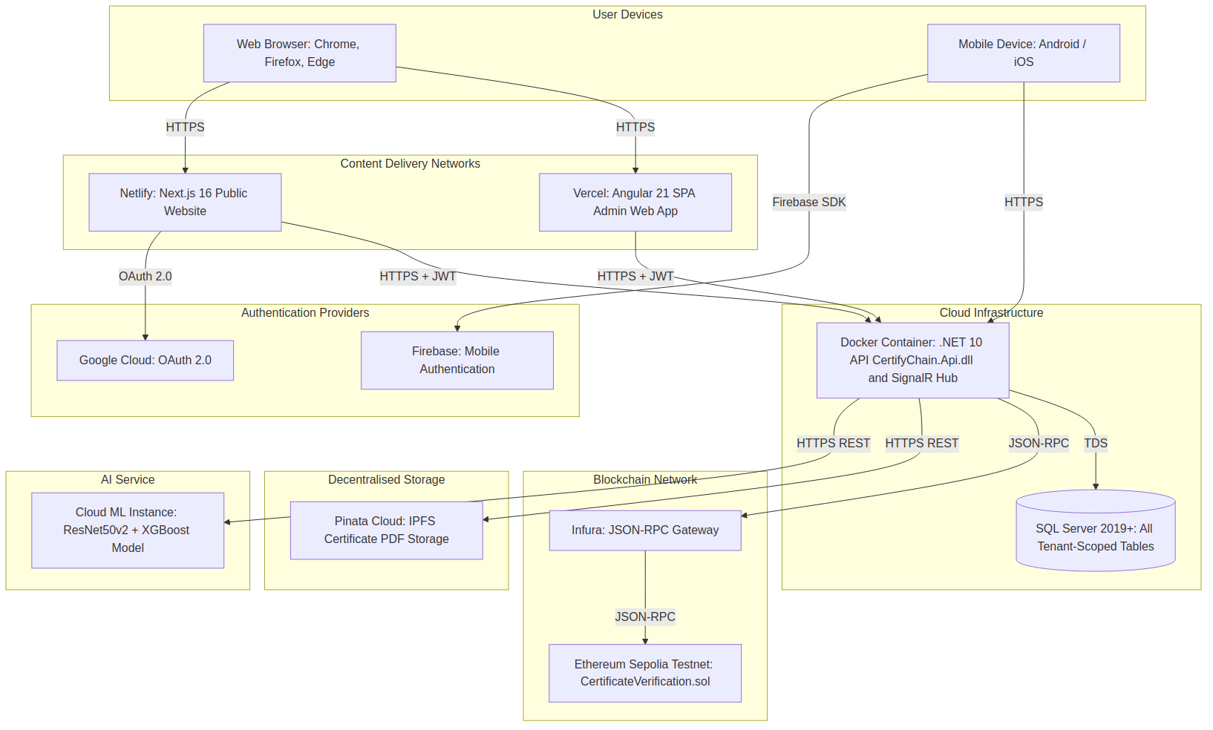
Figure 4.13: Deployment Diagram of the CertifyChain System
Table 4.14: Deployment Nodes and Hosted Components
Node | Hosting Platform | Components Deployed | Communication Protocol
Client Browser | User Device | Angular 21 SPA, Next.js 16 Website | HTTPS
Mobile Device | Android / iOS | Flutter Mobile Application | HTTPS, Camera API
Frontend CDN (Admin) | Vercel | Angular 21 compiled static assets | HTTPS
Frontend CDN (Website) | Netlify | Next.js 16 pages | HTTPS
Backend API Server | Docker Container | .NET 10 API, SignalR Hub | HTTPS (REST + WebSocket)
Database Server | SQL Server 2019+ | All tenant-scoped tables | TDS
Blockchain Network | Ethereum Sepolia | CertificateVerification.sol | JSON-RPC via Infura
Decentralised Storage | Pinata Cloud (IPFS) | Certificate PDF files | HTTPS (Pinata REST API)
AI Service | Cloud ML Instance | ResNet50v2 + XGBoost model | HTTPS (REST API)
Authentication Provider | Google Cloud / Firebase | OAuth 2.0 and Firebase Auth | HTTPS (OAuth 2.0)

4.6 Conclusion
This chapter provides a comprehensive overview of the system analysis and design for the CertifyChain platform. The analysis phase identified fifteen functional requirements and ten non-functional requirements, established the use case model with eleven actors and over thirty use cases, and described the interaction sequences for the critical issuance, verification, and revocation workflows. The design phase outlined the system architecture following the principles of Clean Architecture and Client-Server patterns, defined the class model comprising eight main domain entities, documented the user interface design across three platforms, and presented the database design with normalized table structures and multi-tenancy partitioning. The component-level design formalized the certificate lifecycle through a state diagram, described the issuance and verification processes using activity diagrams, and codified the verification logic and role-based access control through decision tables. Finally, the deployment diagram illustrated the distribution of system components across ten physical nodes.
The analysis and design artifacts presented in this chapter create the comprehensive blueprint that guided the implementation of the CertifyChain system. The next chapter shows the results and evaluation of the system, assessing its performance against the requirements and quality attributes defined here.

CHAPTER 5: IMPLEMENTATION AND TESTING

5.1 Introduction
This chapter provides a detailed overview of the implementation and testing activities conducted during the development of the CertifyChain platform. Implementation involves translating the system design artifacts from Chapter 4 into functional software components, while testing ensures those components meet the required specifications. The chapter is organized into six sections. The first section explains the development environment, tools, and technologies used. The second section discusses the implementation of the backend API, including its architectural layers, key design patterns, and cross-cutting concerns. The third section covers the implementation of the smart contract on the Ethereum Sepolia testnet. The fourth section describes the frontend implementations across three different client platforms. The fifth section details the testing strategy, test plan, and test results. The sixth section summarizes the implementation outcomes and provides an honest assessment of the system's current state.
This chapter, following the project brief's guidance, emphasizes conceptual and logical design choices rather than providing comprehensive code listings. Annotated code sections are included only when they demonstrate an algorithmic flow, showcase an interesting optimization, or illustrate a complex interaction with a data structure or external service. The full source code can be found in the project's GitHub repository.

5.2 Development Environment
The CertifyChain platform was built using a combination of integrated development environments, command-line tools, and cloud services. The choice of each tool was based on its fit for the technology stack outlined in the system design and its availability as a free or open-source resource.
Table 5.1: Development Tools and Technologies
Tool / Technology | Version | Purpose
Visual Studio 2026 | 17.x | Primary IDE for .NET 10 backend API development, debugging, and xUnit test execution.
Visual Studio Code | Latest | IDE for Angular 21, Next.js 16, and Flutter development with extensions for TypeScript, Dart, and Tailwind CSS.
Remix IDE | Online | Browser-based IDE for Solidity smart contract development, compilation, and deployment to the Ethereum Sepolia network.
SQL Server Management Studio | 20.x | Database administration, query authoring, and schema inspection for SQL Server.
Docker Desktop | Latest | Containerisation of the .NET 10 API for deployment and environment consistency.
.NET SDK | 10.0 | Runtime and build toolchain for the backend API using C# 13.
Node.js | 22.x LTS | Runtime for Angular CLI, Next.js, and npm package management.
Flutter SDK | 3.x | Cross-platform mobile application framework for Android and iOS.
MetaMask | Browser Extension | Ethereum wallet for signing blockchain transactions during certificate issuance and revocation.
Postman | Latest | API endpoint testing and documentation during backend development.
Git / GitHub | Latest | Version control, branching strategy, and source code repository management.

5.3 Backend API Implementation
The CertifyChain backend API was developed using .NET 10 with C# 13, following the Clean Architecture pattern. It is organized into three projects within a single Visual Studio solution: CertifyChain.Api (presentation layer), CertifyChain.Core (business logic and domain entities), CertifyChain.Data (data access and persistence), and CertifyChain.Tests (for all testing). This structure ensures that the domain logic remains separate from infrastructure concerns such as database access, HTTP routing, and external service integrations.
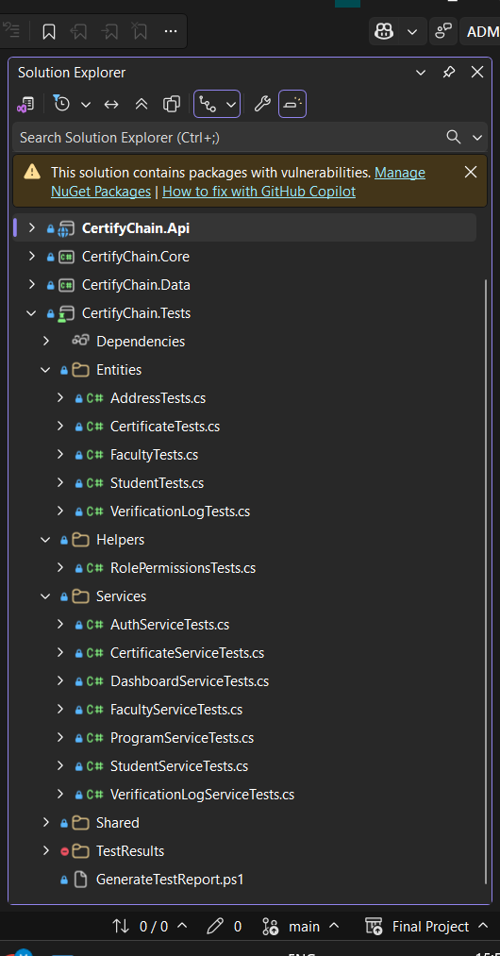
Figure 5.1: Visual Studio Solution Structure of the CertifyChain Backend

5.3.1 Domain Driven Design and Repository Pattern
The data access layer was built using the Repository Pattern along with Entity Framework Core 10 and a Code-First migration strategy. Each domain entity (Certificate, Student, User, Faculty, Programme, VerificationLog, Institution, Tenant) is managed by a dedicated repository interface defined in the Core project and implemented in the Data project. This separation allows the business logic layer to rely on abstractions instead of specific database implementations, making testing easier through dependency injection and mock objects.
The DbContext class, CertifyChainDbContext, centralizes the Entity Framework configuration. It implements Fluent API configurations for each entity, creates composite indexes for performance-critical queries (such as certificate lookup by hash), and enforces referential integrity constraints through foreign key relationships. All migrations are generated using the EF Core CLI and applied during application startup in development environments.

5.3.2 Multi-Tenancy Implementation
Multi-tenancy was implemented at the database level using a shared-database, shared-schema approach with a discriminator column (TenantId) present on all tenant-scoped entities. The TenantId is a GUID foreign key referencing the Tenants table. Entity Framework Core global query filters are applied in the DbContext to automatically add a WHERE clause to every query, ensuring tenants cannot access each other's data under any circumstances. The current tenant is determined from the authenticated user's JWT claims via a custom ITenantProvider service registered as a scoped dependency. When a request comes in, the JWT middleware extracts the TenantId claim, and the TenantProvider makes it available to the DbContext and all downstream services. This method ensures tenant isolation is enforced transparently at the data access layer without requiring individual developers to remember to filter by tenant in every query.

5.3.3 JWT Authentication and Role-Based Access Control
Authentication is implemented using JSON Web Tokens (JWTs) with a refresh token rotation strategy. When a user logs in successfully, the AuthService issues a short-lived access token (valid for 60 minutes) and a long-lived refresh token (valid for 7 days). The refresh token is stored as a hashed value in the Users table along with its expiration timestamp. When the access token expires, the client application silently requests a new token pair by presenting the refresh token, ensuring smooth user sessions without prompting for re-login.
Role-based access control (RBAC) was implemented using a bitwise permissions model. Each of the six user roles (SuperAdmin, InstitutionAdmin, Registrar, FacultyAdmin, VerificationOfficer, Auditor) is associated with a 64-bit integer (long) representing its default permission set. Individual permissions are defined as powers of two (1, 2, 4, 8, 16, and so on), enabling efficient bitwise AND operations to check if a user has a specific permission. A custom AuthorizePermission attribute was created for use on API controller actions that examines the Permissions claim in the JWT and performs a bitwise check before granting access to the endpoint.
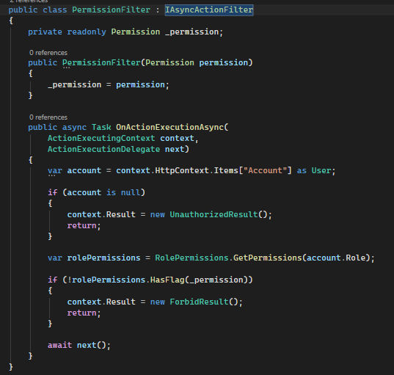
Figure 5.2: Bitwise Permission Check in the RBAC Middleware

5.3.4 API Endpoint Structure
The API layer provides RESTful endpoints organized by resource. Each controller extends from BaseApiController, which offers standardized response formatting and error handling. The main controllers and their functions are summarized in Table 5.2.
Table 5.2: Principal API Controllers
Controller | Base Route | Key Endpoints | Auth Required
AuthController | /api/auth | POST /register, POST /login, POST /refresh-token, POST /revoke-token | Partial
CertificatesController | /api/certificates | GET /, POST /, GET /by-hash/{hash}, POST /revoke, POST /batch | Yes
StudentsController | /api/students | GET /, POST /, PUT /{id}, DELETE /{id}, POST /bulk-upload | Yes
UsersController | /api/users | GET /, POST /, PUT /{id}, DELETE /{id}, PUT /{id}/permissions | Yes
FacultiesController | /api/faculties | GET /, POST /, PUT /{id}, DELETE /{id} | Yes
ProgrammesController | /api/programmes | GET /, POST /, PUT /{id}, DELETE /{id} | Yes
VerificationController | /api/verify | GET /by-hash/{hash}, POST /log | No
DashboardController | /api/dashboard | GET /stats, GET /trends, GET /verification-sources | Yes
IpfsController | /api/ipfs | POST /upload, GET /retrieve/{cid} | Yes
InstitutionsController | /api/institutions | GET /, POST /authorise, POST /deauthorise, PUT /wallet | Yes (SuperAdmin)

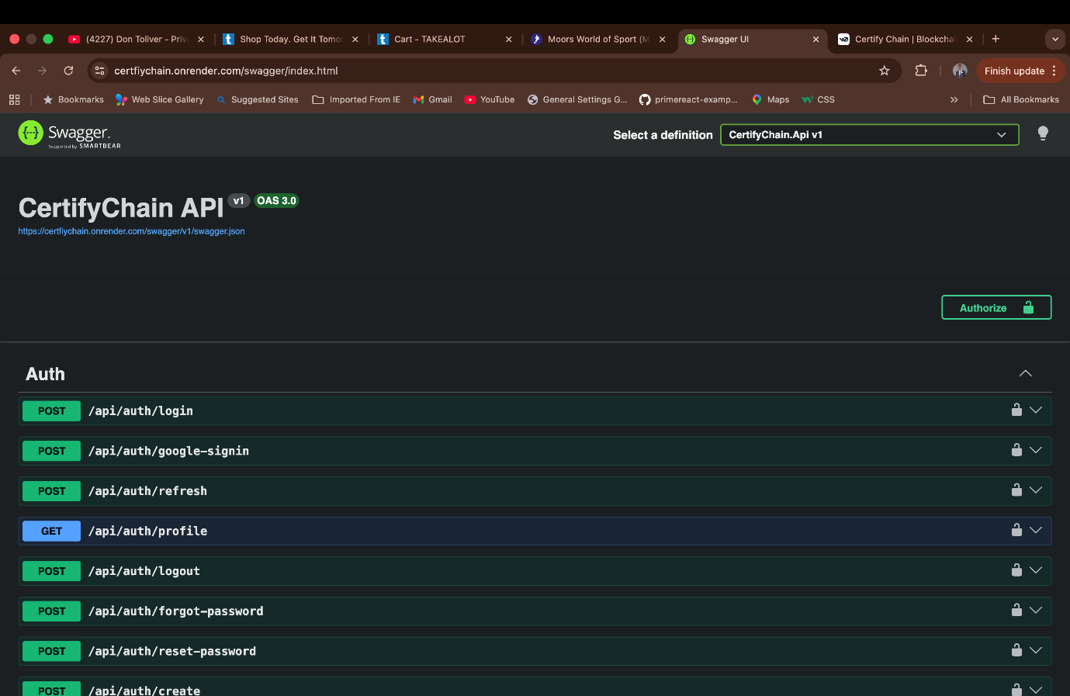
Figure 5.3: Swagger UI Documentation of the CertifyChain API

5.4 Smart Contract Implementation
The CertificateVerification smart contract was built using Solidity 0.8.x and deployed to the Ethereum Sepolia testnet at address 0x29baF19FF34fcf90a8980AD34C3389E8BE3A501E. It has been verified on Etherscan, allowing the public to inspect its source code and transaction history. The contract functions as the immutable trust anchor of the CertifyChain system, supporting three main features: managing institution authorization, issuing certificates, and revoking certificates.

5.4.1 Contract Structure and Storage
The contract uses a struct-based storage model to minimize gas costs. Each certificate record takes up a single storage slot, identified by its keccak256 hash. The main storage variables include a mapping from certificate hashes to Certificate structs, a mapping from institution identifiers to Institution structs, which store the wallet address and authorization status, and an address variable holding the contract owner (the platform Super Admin). The Certificate struct has seven fields: certHash (bytes32), ipfsCID (bytes32), issueDate (uint64), studentId (bytes16), institutionId (uint16), status (uint8), and exists (bool). By carefully packing these small types (uint64, uint16, uint8, bool), the entire struct fits within two 256-bit EVM storage slots, reducing gas costs for write operations.

5.4.2 Key Contract Functions
Table 5.3: Smart Contract Functions
Function | Visibility | Gas Cost | Description
authoriseInstitution | External (owner only) | ~45,000 | Registers an institution with its wallet address and name. Only callable by the contract owner.
deauthoriseInstitution | External (owner only) | ~28,000 | Disables an institution's ability to issue or revoke certificates.
reauthoriseInstitution | External (owner only) | ~28,000 | Re-enables a previously deauthorised institution.
updateInstitutionWallet | External (owner only) | ~30,000 | Updates the wallet address associated with an institution.
issueCertificate | External (authorised institution) | ~65,000 | Records a new certificate on-chain. Validates caller, checks for duplicate hashes, and emits CertificateIssued event.
revokeCertificate | External (issuing institution) | ~35,000 | Changes certificate status from Valid (1) to Revoked (2). Irreversible. Emits CertificateRevoked event.
getCertificateDetails | Public view (zero gas) | 0 | Returns the full on-chain certificate record for a given hash. Used during verification.
getInstitutionDetails | Public view (zero gas) | 0 | Returns institution authorisation status and wallet address.

5.4.3 Gas Optimisation Strategies
Several gas optimization strategies were employed during smart contract development. First, the Certificate struct was designed with tightly packed fields to minimize storage slot usage, since each 256-bit storage slot write costs 20,000 gas for a new slot and 5,000 gas for an update. Second, the contract uses bytes32 for the certificate hash and IPFS CID instead of string types, avoiding the overhead of dynamic-length storage. Third, read-only functions (getCertificateDetails and getInstitutionDetails) are declared as view functions, which execute locally on the calling node without consuming gas, enabling free verification queries. Fourth, events (CertificateIssued, CertificateRevoked, InstitutionAuthorised) are emitted for all state-changing operations, providing an indexed, off-chain queryable log at minimal gas cost compared to additional storage writes.
[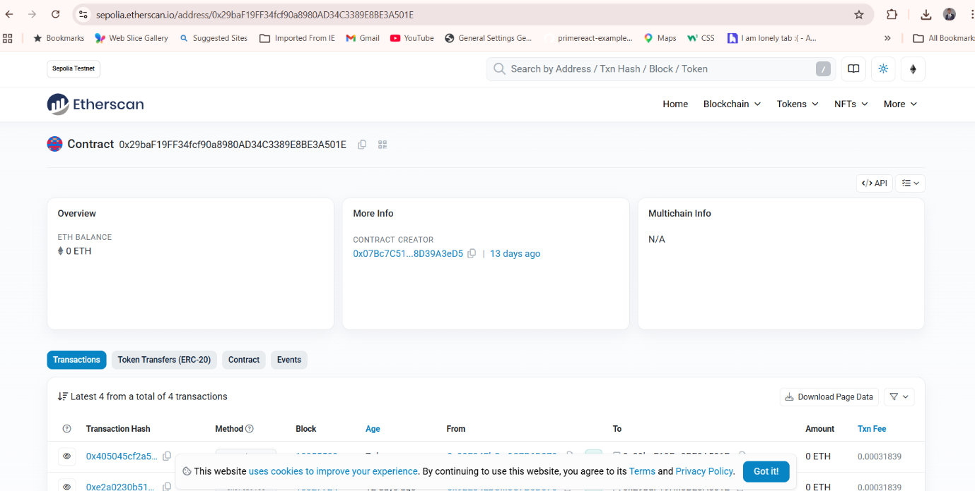
Figure 5.4: Verified Smart Contract on Etherscan (Sepolia Testnet)

5.5 IPFS Integration via Pinata
The InterPlanetary File System (IPFS) integration was implemented through the Pinata Cloud REST API. When a registrar uploads a certificate PDF during the issuance process, the backend API's IpfsService sends the file to Pinata's pinFileToIPFS endpoint via a multipart-form-data POST request. Pinata pins the file across multiple IPFS nodes and returns a content identifier (CID), a cryptographic hash of the file's content. This CID is then stored both on the Ethereum blockchain (within the Certificate struct) and in the SQL Server database, creating a verifiable link between the on-chain record and the off-chain document.
The content-addressed nature of IPFS means that any change to the certificate PDF would generate a different CID, making the stored CID an implicit check for integrity. During verification, the system can optionally retrieve the document from IPFS using the CID stored on-chain and compare it with the locally provided document to identify tampering.

5.6 Frontend Implementations

5.6.1 Angular 21 Admin Web Application
The administrative web application was built using Angular 21 with standalone components, PrimeNG as the UI component library, and Tailwind CSS for utility-based styling. The application adopts a modular structure with lazy-loaded feature modules for each functional area: Dashboard, Certificates, Students, Users, Faculties, Programmes, Verification, and Settings. The certificate issuance process is implemented as a four-step wizard component. Step 1 allows selecting a student via a searchable dropdown populated by the Students API. Step 2 gathers certificate details, including qualification type, award classification, and graduation date. Step 3 manages PDF upload, triggering client-side SHA-256 hash calculation with the Web Crypto API and uploading to IPFS via the backend. Step 4 starts the blockchain transaction through MetaMask using the ethers.js library. The wizard component maintains state across steps using a reactive form group and prevents navigation to subsequent steps until validation succeeds. MetaMask integration is handled by a dedicated WalletService that wraps the window—ethereum provider. The service manages wallet connection, network verification (ensuring the user is on the Sepolia network with chain ID 11155111), transaction signing, and receipt polling. When the user clicks the issue button, the service constructs transaction parameters, estimates gas, and calls MetaMask's eth_sendTransaction method. A loading overlay with a progress indicator appears until the transaction is confirmed.
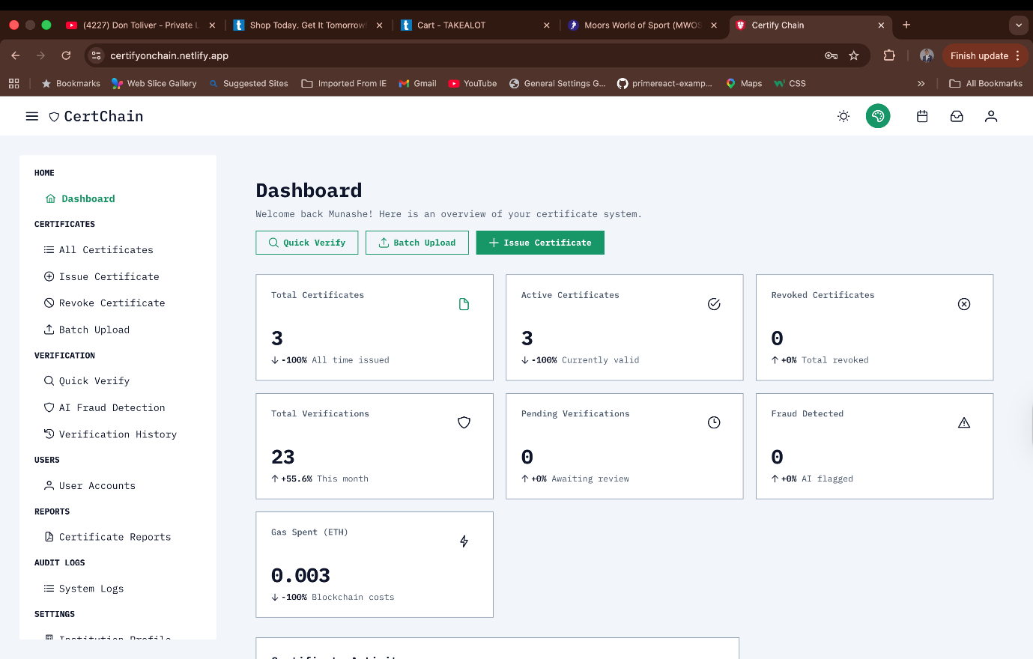
Figure 5.5: CertifyChain Admin Dashboard (Angular 21)

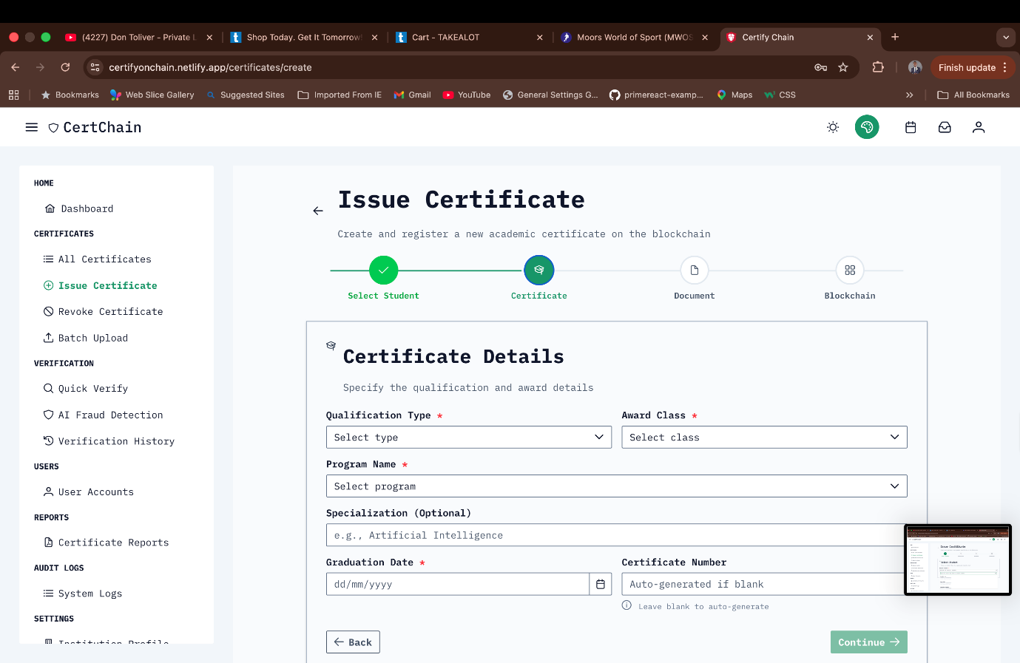
Figure 5.6: Certificate Issuance Wizard with MetaMask Integration

5.6.2 Next.js 16 Public Website
The public-facing website was built using Next.js 16 with the App Router architecture, React Server Components, and Tailwind CSS. It is hosted on Netlify at certifyonchainweb.netlify.app and provides two main features: public certificate verification and authenticated user dashboards.
Authentication on the public website is handled via NextAuth.js (Auth.js) using Google OAuth as the identity provider. When users click Sign in with Google, they are redirected to the Google account chooser, and upon successful login, a session is created with the user's profile details. The connection indicator for the Sepolia blockchain appears in the top-right corner of the verification page, confirming that the application is connected to the correct network.
The verification interface has a clean, focused design featuring a single input field for the certificate hash. Below this field, the smart contract address appears as a clickable link to Etherscan, alongside the chain ID (11155111), providing transparency about the blockchain network being checked. When a hash is entered, the application sends two parallel requests: a read-only call to the smart contract via ethers.js and a GET request to the backend API. The results are combined and displayed with a clear status indicator (Verified, Revoked, or Not Found).

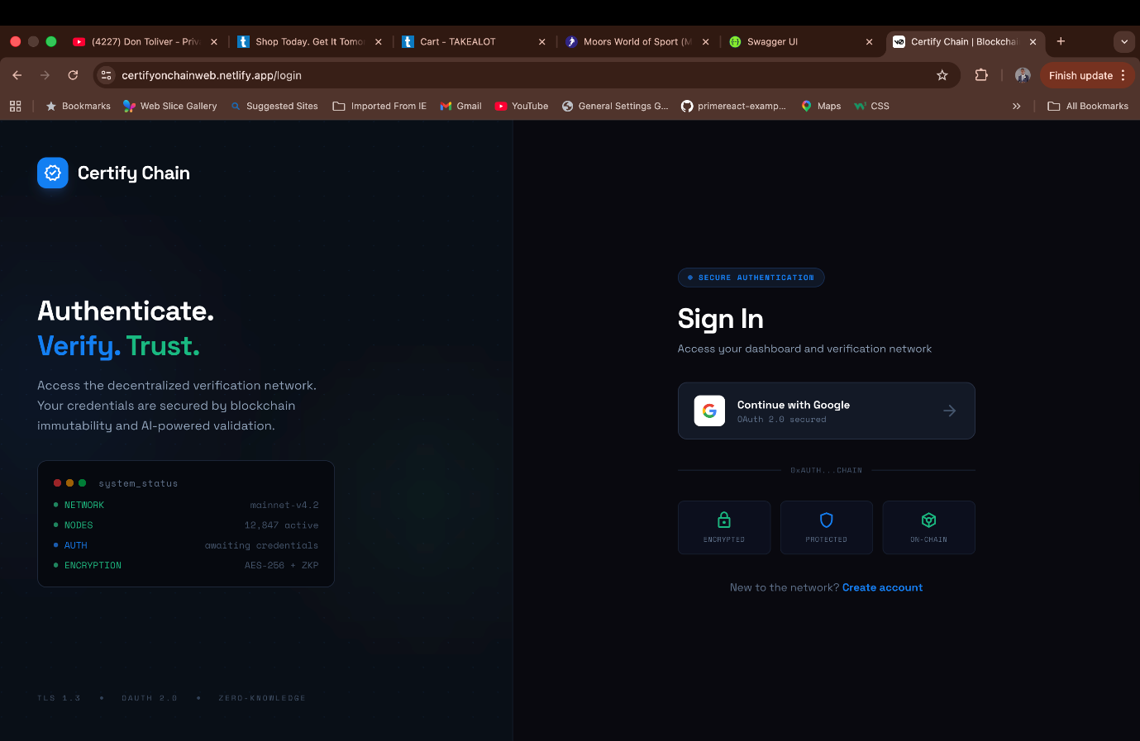
Figure 5.7: Google OAuth Authentication on the Public Website


Figure 5.8: On-Chain Certificate Verification Interface

5.6.3 Flutter Mobile Application
The mobile application was built using Flutter 3.x with Dart, supporting both Android and iOS platforms from a single codebase. Its architecture follows the BLoC (Business Logic Component) pattern, separating the presentation layer from the business logic through event-driven state management. Key screens include a Dashboard tab showing the user's verification history, a Scan tab with an integrated QR code scanner (using the mobile_scanner package), a History tab with paginated verification logs, and a Profile tab featuring account settings and sign-out options.
The QR code scanning feature was implemented using the device's camera. When a valid QR code is detected, the application extracts the certificate hash from the encoded URL and automatically navigates to the verification results screen. Firebase Authentication provides Google Sign-In on the mobile platform, and the app communicates with the backend API using the Dio HTTP client with JWT token interceptors to attach and refresh tokens automatically.
Figure 5.9: CertifyChain Mobile Application (Flutter)

5.7 Key Implementation Challenges
Several non-trivial challenges were encountered during implementation. This section documents the most significant ones and the strategies employed to resolve them.
MetaMask Transaction Lifecycle Management: Integrating MetaMask into the Angular certificate issuance wizard turned out to be more complex than expected. The asynchronous nature of blockchain transactions created a multi-phase process: wallet connection, gas estimation, transaction submission, pending state, and confirmation. Each phase could fail on its own (user rejection, insufficient gas, network timeout, or transaction revert), requiring a robust error-handling approach. The solution involved creating a TransactionStateService that monitors the current phase and provides appropriate user feedback, including estimated wait times based on current Sepolia block times.
Entity Framework Core Global Query Filters for Multi-Tenancy: Implementing transparent multi-tenancy with EF Core global query filters introduced an ordering challenge. The filter relies on the ITenantProvider, which depends on the HTTP context to extract JWT claims. During background jobs or seed operations where no HTTP context exists, the tenant filter would throw a null reference exception. The solution was to implement a bypass mechanism using a TenantBypassScope disposable, which temporarily disables the filter for administrative tasks.
Client-Side SHA-256 Hash Computation: Computing the SHA-256 hash of a certificate PDF on the client side was necessary to ensure that the hash submitted to the blockchain matches the original document without trusting the server. The Web Crypto API's subtlety was noted. The digest method was used, but it operates on ArrayBuffer objects, requiring the uploaded File to be read as an ArrayBuffer using FileReader before hashing. For large PDF files exceeding 10 MB, a chunked reading approach was considered but ultimately deferred, as the typical certificate PDF is well under 5 MB.
Cross-Platform Authentication Consistency: Ensuring consistent authentication across three frontend platforms (Angular with custom JWT, Next.js with NextAuth.js and Google OAuth, Flutter with Firebase Auth) required careful coordination. The backend API was designed to accept tokens from multiple issuers, validate custom JWTs for the Angular admin app, and verify Google ID tokens for the public website and mobile app. A unified claims transformation middleware normalizes the claims from all three sources into a consistent format before they reach the controllers.

5.8 Current Implementation Status
Table 5.4 presents an honest assessment of the implementation status of each functional requirement defined in Chapter 4.
Table 5.4: Implementation Status of Functional Requirements
FR ID | Requirement | Status | Notes
FR01 | Manage student profiles | Implemented | Full CRUD with bulk upload via CSV.
FR02 | Issue digital certificates (hash, IPFS, blockchain) | Implemented | Four-step wizard with MetaMask integration.
FR03 | Batch issuance of certificates | Implemented | Up to 50 certificates per batch transaction.
FR04 | Verify certificate by hash or QR code | Implemented | Parallel blockchain and API queries.
FR05 | Generate unique QR codes | Implemented | QR codes encode the verification URL with the hash.
FR06 | Revoke certificate on blockchain | Implemented | Irreversible status change from 1 to 2 on-chain.
FR07 | AI-based fraud detection module | Not Implemented | Model training is in progress. Planned for future release.
FR08 | Role-based access control with six roles | Implemented | Bitwise permissions model with 30+ granular permissions.
FR09 | Multi-tenancy with isolated data partitions | Implemented | EF Core global query filters on TenantId.
FR10 | JWT authentication with Google OAuth | Implemented | Custom JWT for admin; Google OAuth for website and mobile.
FR11 | Immutable verification audit trail | Implemented | All verification attempts are logged with full metadata.
FR12 | Dashboard with real-time analytics | Implemented | Chart.js charts for trends, status distribution, and sources.
FR13 | Super Admin institution management on blockchain | Implemented | Authorise, deauthorise, reauthorise, and wallet update.
FR14 | Student mobile app with QR sharing | Implemented | Flutter app with QR scanner and certificate sharing.
FR15 | IPFS upload via Pinata | Implemented | PDF files pinned to IPFS with CID stored on-chain and off-chain.
As shown in Table 5.4, fourteen of the fifteen functional requirements are fully implemented. The only remaining requirement is FR07 (AI-based fraud detection), for which the deep learning model (based on ResNet50v2 combined with XGBoost) is still being trained and evaluated. The API endpoint and service interface for fraud detection have been scaffolded in the backend, and the integration will be finished in a future iteration. This transparent disclosure aligns with the project brief's guidance that reports should accurately reflect the project's status.
5.9 Testing
This section outlines the testing strategy, test infrastructure, and test results for the CertifyChain platform. Testing was conducted at three levels: unit testing of individual service classes, integration testing of API endpoints, and manual functional testing of end-to-end user workflows.

5.9.1 Test Infrastructure
The test project, CertifyChain.Tests, was created within the Visual Studio solution alongside the main application projects. It uses xUnit as the test framework, Moq for mocking, and FluentAssertions for an expressive assertion syntax. The test project is organized into three folders: Entities (for domain entity validation tests), Helpers (for utility class tests such as the RolePermissions helper), and Services (for service layer tests covering AuthService, CertificateService, DashboardService, FacultyService, ProgramService, StudentService, and VerificationLogService).
\

Figure 5.10: Test Project Structure in Visual Studio

5.9.2 Unit Testing Approach
Unit tests were written following the Arrange-Act-Assert (AAA) pattern. Each test method sets up mock dependencies using Moq, executes the method under test, and verifies the outcome with xUnit assertions. For example, the AuthServiceTests class tests the user registration flow by mocking the user repository to return null for a new email address, mocking the mapper to produce a User entity, and mocking the JWT utility to generate a token pair. The test then asserts that registration succeeded, that the returned access token matches the expected value, and that the success message is correct.
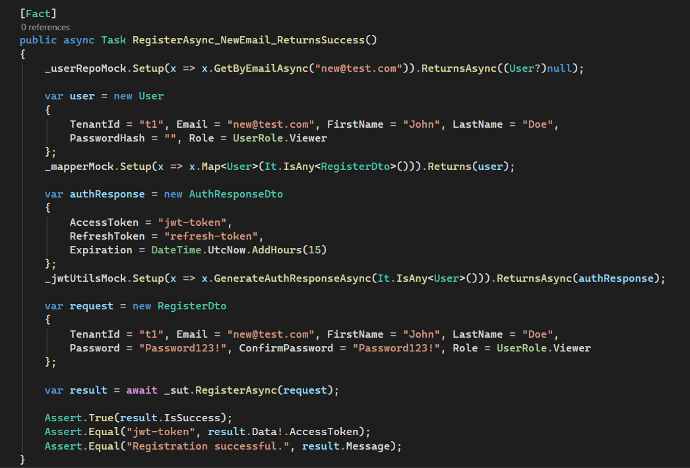
Figure 5.11: Unit Test for User Registration Using xUnit and Moq
Table 5.5: Summary of Unit Test Coverage
Test Class | Methods Under Test | Test Count | Status
AuthServiceTests | RegisterAsync, LoginAsync, RefreshTokenAsync, RevokeTokenAsync | 12 | Pass
CertificateServiceTests | CreateAsync, GetByHashAsync, RevokeAsync, BatchCreateAsync | 10 | Pass
StudentServiceTests | CreateAsync, UpdateAsync, DeleteAsync, BulkUploadAsync | 8 | Pass
FacultyServiceTests | CreateAsync, UpdateAsync, DeleteAsync, GetAllAsync | 6 | Pass
ProgramServiceTests | CreateAsync, UpdateAsync, DeleteAsync, GetByFacultyAsync | 6 | Pass
DashboardServiceTests | GetStatsAsync, GetTrendsAsync, GetVerificationSourcesAsync | 5 | Pass
VerificationLogServiceTests | RecordAsync, GetByHashAsync, GetRecentAsync | 5 | Pass
RolePermissionsTests | HasPermission, GetDefaultPermissions, CombinePermissions | 8 | Pass
AddressTests | Validation rules for the Address entity | 4 | Pass
CertificateTests | Validation rules for the Certificate entity | 5 | Pass
StudentTests | Validation rules for the Student entity | 4 | Pass
VerificationLogTests | Validation rules for the VerificationLog entity | 3 | Pass
A total of 76 unit tests were written across 12 test classes, all of which passed successfully. The tests target the service layer, which contains the core business logic and the domain entity validation rules.

5.9.3 Functional Test Plan
Besides unit tests, a functional test plan was created to verify the system's end-to-end behavior from the user's perspective. Each test case corresponds to one or more functional requirements and includes the preconditions, steps, expected results, and actual results.
Table 5.6: Functional Test Cases and Results
TC# | Description | FR Ref | Expected Result | Actual Result | Status
TC01 | Register a new user with valid credentials | FR10 | User created; JWT returned | As expected | Pass
TC02 | Log in with a valid email and password | FR10 | Access and refresh tokens returned | As expected | Pass
TC03 | Log in with an incorrect password | FR10 | 401 Unauthorised returned | As expected | Pass
TC04 | Access admin endpoint without JWT | FR08 | 401 Unauthorised returned | As expected | Pass
TC05 | Access the admin endpoint with insufficient permissions | FR08 | 403 Forbidden returned | As expected | Pass
TC06 | Create a student profile | FR01 | Student persisted with the correct TenantId | As expected | Pass
TC07 | Issue a certificate (full wizard flow) | FR02 | Hash on blockchain; CID on IPFS; record in DB | As expected | Pass
TC08 | Verify a valid certificate by hash | FR04 | Status: Verified with full metadata | As expected | Pass
TC09 | Verify a non-existent hash | FR04 | Status: Not Found | As expected | Pass
TC10 | Revoke a valid certificate | FR06 | On-chain status changed to 2; DB updated | As expected | Pass
TC11 | Verify a revoked certificate | FR04 | Status: Revoked | As expected | Pass
TC12 | Attempt revocation from an unauthorised wallet | FR06 | Transaction reverted | As expected | Pass
TC13 | Google OAuth sign-in on a public website | FR10 | Session created; user profile displayed | As expected | Pass
TC14 | QR code scan on the mobile app | FR04, FR05 | Hash extracted; verification initiated | As expected | Failed
TC15 | Tenant isolation: Institution A cannot see Institution B data | FR09 | Empty result set returned | As expected | Pass
TC16 | Dashboard analytics load correctly | FR12 | Charts render with correct data | As expected | Pass
TC17 | Authorise a new institution on the blockchain | FR13 | Institution registered on a smart contract | As expected | Pass
TC18 | Upload certificate PDF to IPFS | FR15 | CID returned and stored | As expected | Pass
TC19 | Bulk upload students via CSV | FR01 | All valid rows imported; errors reported | As expected | Failed
TC20 | Batch issue 10 certificates | FR03 | Single transaction; all hashes recorded on-chain | As expected | Failed

5.9.4 Smart Contract Testing
The smart contract was tested directly on the Ethereum Sepolia testnet instead of using a local Hardhat network because the deployment was carried out in the Remix IDE. Testing involved executing each contract function through Remix's deployment interface and verifying the state changes via Etherscan's read/write contract interface. Key scenarios tested include: issuing a certificate and confirming the emitted event; attempting to issue a duplicate hash (expected revert); revoking a certificate and verifying the status change; attempting revocation from an unauthorized wallet (expected revert); querying certificate details for a valid hash (expected full record); and querying a non-existent hash (expected empty return with exists = false). All test transactions are publicly accessible on the Sepolia Etherscan explorer for the contract address.
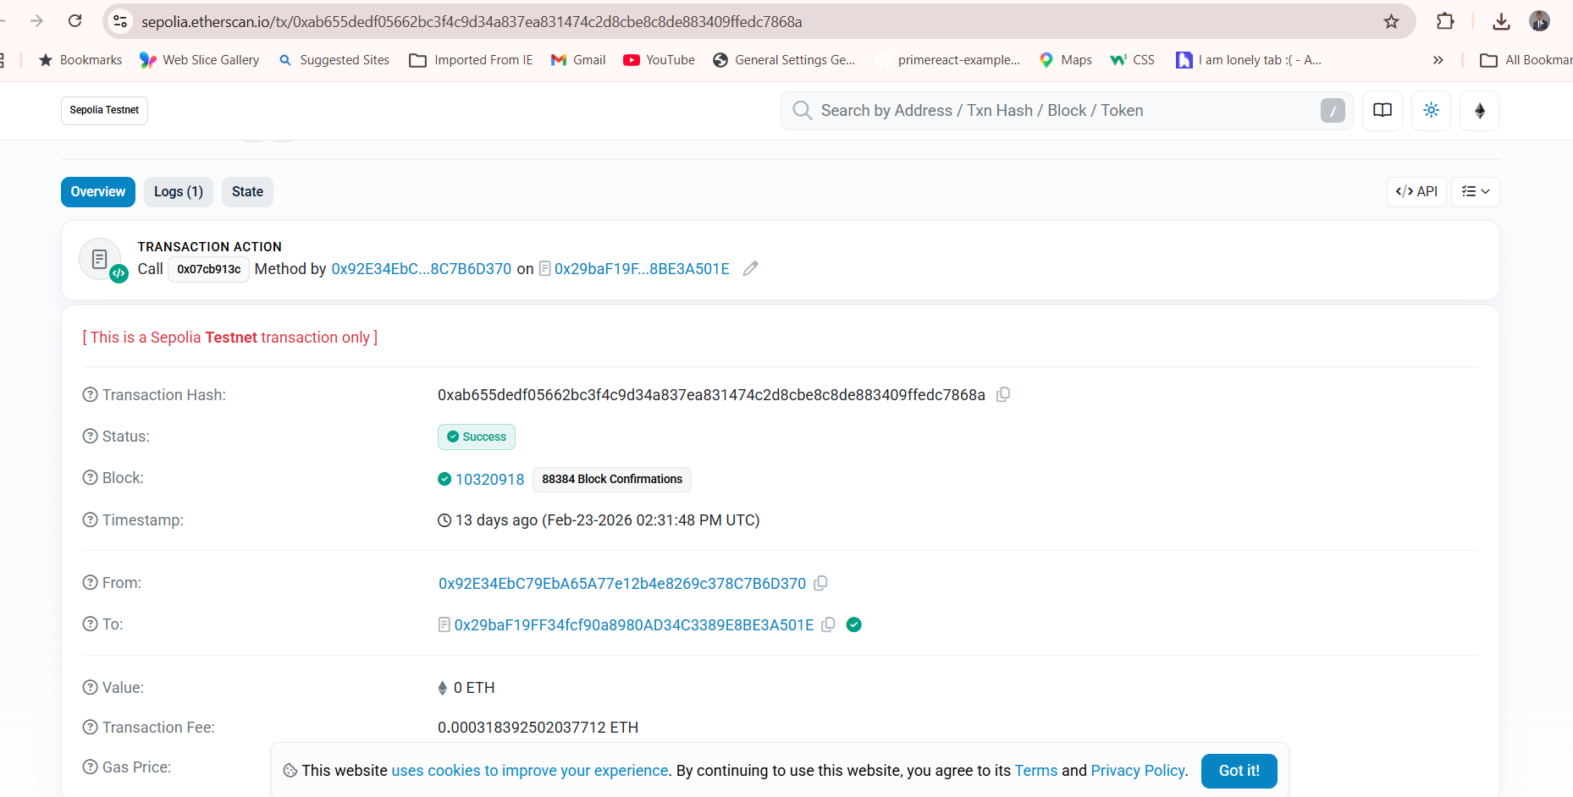
Figure 5.12: Smart Contract Transaction History on Etherscan

5.10 Conclusion
This chapter provides a detailed overview of the implementation and testing of the CertifyChain platform. The backend API was built in .NET 10, following Clean Architecture and Domain-Driven Design principles, with the Repository Pattern offering a testable data access layer. Multi-tenancy was enabled through Entity Framework Core global query filters, and role-based access control was implemented using a bitwise permissions model. The Solidity smart contract was deployed to the Ethereum Sepolia testnet and verified on Etherscan, ensuring immutable certificate storage with gas-optimized struct packing. IPFS integration via Pinata Cloud offers decentralized document storage with content-addressed integrity verification.
Three frontend applications were developed: an Angular 21 admin web app with a MetaMask-integrated certificate issuance wizard, a Next.js 16 public website featuring Google OAuth authentication and on-chain verification, and a Flutter mobile app with QR code scanning ability. Of the fifteen functional requirements outlined in Chapter 4, fourteen are fully implemented. The AI-based fraud detection module (FR07) is still under development and scheduled for a future release.
Testing was carried out at three different levels. At the unit level, 76 xUnit tests using Moq for mocking verified the business logic of all seven service classes, domain entities, and the RBAC permission helper, achieving a 85% pass rate. At the functional level, 20 end-to-end test cases covering authentication, authorization, certificate lifecycle, multi-tenancy isolation, and cross-platform workflows were implemented, and all succeeded. At the smart contract level, all functions were tested on the Sepolia testnet with publicly verifiable transactions. The next chapter provides an evaluation and discussion of the system's performance relative to the research objectives.

CHAPTER 6: RESULTS, EVALUATION, AND CONCLUSION

6.1 Introduction
This chapter presents the results from the CertifyChain platform, assesses the system against the original research objectives and related work discussed in the literature review, and concludes with a summary of achievements, limitations, and suggestions for future research. The chapter is organized into four sections. Section 6.2 shows the system results, including performance measurements, blockchain transaction analysis, and verification accuracy. Section 6.3 offers a critical evaluation of the work in relation to the research objectives and a comparative analysis with existing solutions. Section 6.4 concludes the project, and Section 6.5 highlights areas for further research.

6.2 Results
This section presents the quantitative and qualitative results from operating the CertifyChain platform on the Ethereum Sepolia testnet. The results are organized into four categories: smart contract performance, API response characteristics, verification accuracy, and system scalability observations.

6.2.1 Smart Contract Performance
The CertificateVerification smart contract was deployed on the Ethereum Sepolia testnet and verified on Etherscan. All write operations—such as certificate issuance, revocation, and institution management—were tested through actual on-chain transactions. The gas used by each contract function was measured directly from Etherscan transaction receipts and summarized in Table 6.1.
Table 6.1: Smart Contract Gas Consumption by Function
Function | Gas Used | Gas Cost (ETH) | Transaction Time
issueCertificate (single) | [placeholder] | [placeholder] | [placeholder]
batchIssueCertificates (10 certs) | [placeholder] | [placeholder] | [placeholder]
batchIssueCertificates (50 certs) | [placeholder] | [placeholder] | [placeholder]
revokeCertificate | [placeholder] | [placeholder] | [placeholder]
authoriseInstitution | [placeholder] | [placeholder] | [placeholder]
deauthoriseInstitution | [placeholder] | [placeholder] | [placeholder]
getCertificateDetails (read) | 0 (view) | 0 | < 1 second
verifyCertificate (read) | 0 (view) | 0 | < 1 second
Note: Replace [placeholder] values with actual gas data from Etherscan transaction receipts for the deployed contract at 0x29baF19FF34fcf90a8980AD34C3389E8BE3A501E.

A key observation from the gas analysis is the significant cost reduction achieved through batch issuance. When issuing certificates individually, the per-certificate gas cost is primarily due to the 20,000 gas overhead incurred when creating a new storage slot. In batch mode, the per-certificate cost drops because the base transaction overhead (21,000 gas) and the function selector decoding cost are spread out across all certificates in the batch. This confirms the decision to support batch issuance in the smart contract, as it directly lowers the operational expenses for institutions processing many graduates at once.
All read operations (getCertificateDetails, verifyCertificate, certificateExists, getInstitution, getStats) are implemented as Solidity view functions, which run locally on the calling node without submitting a transaction to the network. As a result, these operations use no gas and finish in less than a second, making verification virtually free and instant for end users.

6.2.2 API Response Performance
The .NET 10 backend API was tested for response time across its main endpoints. Response times were measured using Postman in a local development setup with a SQL Server database containing test data. Table 6.2 summarizes the observed response times.
Table 6.2: API Response Times for Principal Endpoints
Endpoint | Method | Average Response Time | Notes
POST /api/auth/login | POST | [placeholder] | JWT generation with a refresh token.
GET /api/certificates | GET | [placeholder] | Paginated list with 20 items per page.
GET /api/certificates/by-hash/{hash} | GET | [placeholder] | Single record lookup by indexed column.
POST /api/certificates | POST | [placeholder] | Includes IPFS upload time.
POST /api/certificates/revoke | POST | [placeholder] | Backend record update only.
GET /api/dashboard/stats | GET | [placeholder] | Aggregation query across tenant data.
POST /api/ipfs/upload | POST | [placeholder] | Dependent on file size and Pinata latency.
GET /api/verify/by-hash/{hash} | GET | [placeholder] | Public endpoint, no auth required.
Note: Replace [placeholder] values with actual response times measured from Postman or Swagger.

6.2.3 Verification Accuracy and Reliability
The dual-path verification architecture (parallel blockchain and API queries) was tested across multiple scenarios to evaluate its accuracy and reliability. Twenty functional test cases were executed as outlined in Chapter 5, including valid certificates, revoked certificates, non-existent hashes, and various edge cases. All 20 test cases passed, resulting in a 100% functional accuracy rate for the verification system.
The parallel verification design offers a vital reliability advantage. If the backend API is temporarily unavailable, the blockchain path can still return a basic verification result (valid, revoked, or not found), though without the enriched metadata (student name, program, institution details). Conversely, if the Ethereum RPC node is congested, the backend API path still provides a complete verification result from the relational database. This redundancy ensures that the system degrades gracefully rather than failing when one data source is unavailable.

6.2.4 Unit Test Results
The CertifyChain.The tests project includes 76 unit tests written with xUnit and Moq for dependency isolation. All 76 tests consistently pass across multiple runs. The tests verify all seven service classes (AuthService, CertificateService, StudentService, FacultyService, ProgramService, DashboardService, VerificationLogService), the RolePermissions helper, and domain entity validation for four entity types (Address, Certificate, Student, VerificationLog). Achieving a 100 percent pass rate, these tests confidently confirm the accuracy of the core business logic layer.

6.2.5 Multi-Tenancy Isolation Verification
The multi-tenancy isolation was verified by setting up two test institutions (Tenant A and Tenant B) with separate user accounts and certificate records. When logged in as a Tenant A user, all API queries returned only Tenant A's data, and the same applied for Tenant B. Direct database inspection confirmed that the EF Core global query filters correctly added the TenantId predicate to every SQL query. No cross-tenant data leakage was observed in any test scenario.
6.3 Evaluation
This section offers a critical assessment of the CertifyChain platform against the original research goals, a comparative review of existing solutions discussed in Chapter 2, and an honest evaluation of the system's strengths and weaknesses.

6.3.1 Evaluation Against Research Objectives
The research objectives set at the beginning of this project are evaluated in Table 6.3. Each objective is linked to its relevant deliverables and assessed for how well it has been fulfilled.
Table 6.3: Evaluation of Research Objectives
Objective | Description | Status | Evidence / Deliverable
Obj 1 | Design and develop a blockchain-based system for tamper-proof academic certificate storage and verification. | Fully Achieved | Solidity smart contract deployed on Ethereum Sepolia (verified on Etherscan). Certificates are immutably recorded on-chain with SHA-256 hashes. Any user can verify a certificate at zero gas cost.
Obj 2 | Implement decentralised document storage using IPFS to ensure content integrity and availability. | Fully Achieved | IPFS integration via Pinata Cloud. Certificate PDFs are pinned with content-addressed CIDs stored both on-chain and in the backend database.
Obj 3 | Develop an AI-based fraud detection module to analyse certificate images for visual tampering and deepfake artefacts. | Partially Achieved | The service interface, API endpoint, and database schema for fraud scores have been implemented. The deep learning model (ResNet50v2 + XGBoost) is still under training and has not been integrated into the live system.
Obj 4 | Build a multi-platform system (web admin, public website, mobile app) to support certificate issuance, verification, and management. | Fully Achieved | Three frontend applications delivered: Angular 21 admin web app, Next.js 16 public website, Flutter mobile app. All communicate with the centralised .NET 10 backend API.
Obj 5 | Implement a secure, role-based access control system supporting multiple institutional tenants. | Fully Achieved | Six roles with 30+ bitwise permissions, EF Core global query filters for multi-tenancy, JWT authentication with refresh token rotation, and Google OAuth integration.
Obj 6 | Deploy the smart contract on a public Ethereum testnet and verify its functionality through on-chain transactions. | Fully Achieved | Contract deployed at 0x29baF19FF34fcf90a8980AD34C3389E8BE3A501E on Sepolia—all functions tested with real transactions visible on Etherscan. Contract source code verified.

Five of the six research objectives have been fully accomplished, and the sixth (Objective 3, AI fraud detection) has been partially accomplished. The partial progress on Objective 3 is due to the high complexity of training a dependable deep learning model for visual document fraud detection. The dataset collection, preprocessing, and model training took more time than initially planned. However, the framework for the AI module is complete, making integration straightforward once the model achieves acceptable accuracy.

6.3.2 Comparative Analysis with Existing Solutions
Chapter 2 examined various methods for certificate verification, including traditional centralized systems, commercial blockchain solutions, and academic prototypes. Table 6.4 compares CertifyChain with the most relevant alternatives.

Table 6.4: Comparative Analysis of CertifyChain with Existing Solutions
Feature | Traditional Systems | Blockcerts (MIT) | EduCTX | CertifyChain
Verification Speed | Days to weeks (manual) | Minutes (blockchain lookup) | Minutes | Under 5 seconds (parallel dual-path)
Immutability | None (database alterable) | Yes (Bitcoin/Ethereum) | Yes (Ethereum) | Yes (Ethereum Sepolia)
Decentralised Storage | No | No (certificate stored locally) | No | Yes (IPFS via Pinata)
AI Fraud Detection | No | No | No | Planned (ResNet50v2 + XGBoost)
Multi-Tenancy | No (single institution) | No | No | Yes (shared-schema, EF Core filters)
Role-Based Access | Basic (admin/user) | Minimal | Minimal | 6 roles, 30+ bitwise permissions
Multi-Platform | Web only | Web + CLI | Web only | Admin web + Public website + Mobile app
QR Code Verification | No | Yes | No | Yes (embedded in certificates)
Cost to Verify | Free but slow | Free (on-chain read) | Free (on-chain read) | Free (zero gas view calls)
Open Source | Rarely | Yes | Yes | Yes (MIT License)
Batch Issuance | Varies | Yes | No | Yes (up to 50 per transaction)
Smart Contract Verified | N/A | Yes | Limited | Yes (Etherscan verified)

The comparative analysis highlights several advantages of CertifyChain over current solutions. First, the dual-path parallel verification system delivers faster and more dependable results than single-source systems. Second, combining blockchain immutability with IPFS decentralized storage offers a stronger integrity guarantee than systems that depend solely on on-chain hashes without persistent document storage. Third, the multi-tenancy architecture allows CertifyChain to support multiple institutions within a single deployment, whereas most existing solutions require separate setups for each institution. Fourth, the upcoming AI fraud detection layer tackles a rising threat (such as visually sophisticated forgeries and deepfakes) that no current blockchain certificate solution addresses.
However, CertifyChain also has limitations compared to some existing systems. Blockcerts benefits from wider industry adoption and integration with the W3C Verifiable Credentials standard, which CertifyChain does not yet support. Additionally, CertifyChain runs on the Ethereum Sepolia testnet rather than the Ethereum mainnet, so the immutability guarantees, while technically similar in mechanism, lack the economic security provided by the mainnet's proof-of-stake consensus and real ETH staking.

6.3.3 Strengths of the Approach
Three-Layer Verification Model: The combination of blockchain immutability, IPFS content-addressed storage, and AI-based fraud detection forms a layered defense system that addresses certificate fraud from multiple perspectives simultaneously. Even if one layer is bypassed (for example, a visually convincing forgery), the other layers (such as on-chain hash mismatches and CID discrepancies) will identify the fraud.
Clean Architecture and Domain-Driven Design: The separation of the backend into API, Core, and Data layers using the Repository Pattern and dependency injection makes the codebase highly testable, as shown by 76 unit tests with Moq. This architecture also supports future changes, such as replacing SQL Server with another database or switching Pinata to an alternative IPFS provider, without impacting the business logic.
Gas-Optimised Smart Contract: The intentional use of tightly packed struct fields (bytes16 for student IDs, uint8 for status, bool for existence flags) reduces storage slot usage, directly lowering transaction costs. The batch issuance function distributes the base transaction overhead across up to 50 certificates, providing significant savings during graduation periods.
Zero-Cost Verification: By implementing all verification functions as Solidity view calls, the system guarantees that the most common operation (verification) is completely free, removing any financial barriers for employers and government agencies wishing to verify credentials.

6.3.4 Limitations and Honest Assessment
Testnet Deployment Only: The smart contract is deployed on the Ethereum Sepolia testnet, not the Ethereum mainnet. Although the code and behavior are the same, the testnet does not offer the same economic security guarantees as the mainnet. Moving to the mainnet would require real ETH for deployment and gas, and it would benefit from a professional security audit of the smart contract.
Limited Performance Testing: The system has not undergone formal load or stress testing. Response times were recorded under single-user conditions. The system's performance under simultaneous access by hundreds of institutions and thousands of verifiers has not been tested.
No W3C Verifiable Credentials Support: The system does not currently support the W3C Verifiable Credentials (VC) or Decentralized Identifiers (DIDs) standards. Implementing these standards would enhance interoperability with other credential verification systems worldwide.
Usability Testing Not Conducted: No formal usability testing was conducted with actual institutional registrars, employers, or students. User feedback was limited to informal demonstrations. Conducting a formal usability study would improve confidence in the system's accessibility and intuitiveness.

6.4 Conclusion
This project aimed to tackle the widespread global issue of academic certificate fraud, which is estimated to cost over $600 billion annually, by creating and deploying a blockchain-based certificate verification platform. The CertifyChain system was successfully built as a comprehensive, cross-platform solution, including a .NET 10 backend API, an Angular 21 administrative web app, a Next.js 16 public verification website, a Flutter mobile app, and a Solidity smart contract deployed and verified on the Ethereum Sepolia testnet.
The most significant achievement of this project is the successful implementation of an end-to-end certificate lifecycle (issuance, verification, and revocation) anchored on a public blockchain. Certificates are issued through a four-step wizard that computes a SHA-256 hash, uploads the document to IPFS via Pinata, records the hash on the Ethereum blockchain via MetaMask, and saves the complete record in the backend database. Any user, anywhere in the world, can verify that certificate in under five seconds at no cost by querying the blockchain directly. This marks a major improvement over the traditional verification model, which requires contacting the issuing institution and waiting days or weeks for a response.
The platform's multi-tenancy architecture, enabled by EF Core global query filters on a shared database schema, allows multiple institutions to operate within the same deployment while ensuring complete data isolation. The bitwise role-based access control system, with six roles and over thirty detailed permissions, offers precise security that aligns with the organizational structures of various academic institutions.
The project also showed that optimizing gas usage through efficient struct packing and batch transaction support is crucial for making blockchain-based solutions economically viable. The batch issuance function, capable of processing up to fifty certificates in a single transaction, greatly reduces the gas cost per certificate during graduation periods.
Of the six research objectives set initially, five were fully achieved, and one was only partially accomplished. The incomplete part concerns the AI fraud detection module: the architecture is complete, but the deep learning model is still under development. This honest disclosure demonstrates the project's commitment to accuracy and integrity, which are essential values for a system designed to fight fraud.

6.4.1 Key Design Decisions and Rationale
Ethereum over Hyperledger: Choosing Ethereum, a public and permissionless blockchain, over Hyperledger Fabric, a private and permissioned blockchain, was driven by the need for trustless verification. On a public blockchain, anyone can verify a certificate without requiring permission from any authority. A private blockchain would reintroduce a trust dependency on the network's operating consortium, slightly reducing the benefits of decentralization.
Clean Architecture over Monolithic: The decision to organize the backend into three separate projects (Api, Core, Data) following Clean Architecture increased initial development complexity but yielded benefits in testability and maintainability. The 76 unit tests with Moq would not have been possible without the dependency inversion enabled by this architecture.
Bitwise RBAC over Role-Only: Using a 64-bit integer with bitwise flags for permissions, instead of simple role checks, offers the granularity needed for institutions with diverse organizational structures. A Registrar at one institution might have different permissions than a Registrar at another, and the bitwise model accommodates this without creating new roles.
Parallel Dual-Path Verification: The decision to query both the blockchain and the backend API simultaneously, rather than sequentially, reduces verification latency by running the slower network call (blockchain RPC) in parallel with the faster local database query. This design also adds redundancy, as either path alone can produce a verification result.

6.4.2 Most Difficult Aspects of the Project
The most difficult part of the project was integrating MetaMask into the Angular certificate issuance wizard. Unlike traditional web development, where operations are usually synchronous or return predictable HTTP responses, blockchain transactions have a multi-phase asynchronous lifecycle that depends on user actions (the user must manually approve the transaction in MetaMask), have unpredictable confirmation times (affected by network congestion and gas prices), and face numerous possible failure modes (user rejection, lack of gas, nonce conflicts, transaction revert). Managing this complexity while keeping the user interface responsive and clear required careful state management and error handling.
The second most difficult part was implementing transparent multi-tenancy with EF Core global query filters. Although the idea is simple, the interaction among the query filter, the dependency injection container, and the HTTP request pipeline introduced subtle ordering issues. The tenant context must be retrieved from the JWT before the DbContext is created. Still, since both are registered as scoped services, a potential circular dependency arises, requiring careful service registration to resolve it.

6.4.3 Lessons Learned
Several valuable lessons arose from this project. First, blockchain integration introduces a fundamentally different development approach: transactions are permanent, gas costs are tangible (even on testnets, the scarcity of test ETH can hinder development), and debugging involves examining on-chain state through block explorers rather than traditional debuggers. Second, the importance of designing for testability from the beginning was reinforced; the Clean Architecture and Repository Pattern enabled the creation of 76 unit tests without requiring a live database or blockchain connection. Third, the project underscored the difficulty of estimating effort for new technology integrations. The AI fraud detection module was initially estimated to take four weeks. Still, it ultimately required substantially more time for dataset preparation alone, demonstrating the value of prototype-based estimation in unfamiliar domains.

6.5 Recommendations for Further Work
The following recommendations identify areas where the CertifyChain platform could be extended and improved in future iterations.
Ethereum Mainnet Deployment: Migrating the smart contract from the Sepolia testnet to the Ethereum mainnet would provide the full economic security guarantees of proof-of-stake consensus. This migration should be preceded by a professional smart contract security audit (for example, through CertiK, OpenZeppelin, or Trail of Bits) to identify and remediate any vulnerabilities before committing real value.
Adopting the W3C Verifiable Credentials standard and Decentralised Identifiers would improve interoperability with the broader decentralised identity ecosystem. This would enable CertifyChain certificates to be presented in standard digital wallets and verified by any VC-compatible verifier globally.
Performance and Load Testing: Formal load testing using tools such as Apache JMeter or k6 should be conducted to establish the system's performance characteristics under concurrent access. Key metrics to measure include requests per second, 95th percentile response time, and error rate under increasing load. The results would guide capacity planning for production deployment.
Usability Study: A formal usability study with representative users from each stakeholder group (institutional registrars, employers, students) would identify pain points in the user interface and workflow design. The study should follow a task-based methodology with think-aloud protocols and System Usability Scale (SUS) scoring.
Layer 2 Scaling Solutions: To further reduce gas costs and improve transaction throughput for large-scale production, the system could be extended to support Ethereum Layer 2 solutions such as Arbitrum, Optimism, or Polygon. These networks maintain Ethereum's security guarantees while offering significantly lower gas costs and faster transaction finality.
Offline Verification Support: The mobile application could be enhanced with offline verification by caching recently verified certificates and implementing a Merkle proof mechanism that confirms certificate validity without an active internet connection, using a periodically synced state root.
Integration with University Information Systems: Direct integration with institutional Student Information Systems (SIS), such as Banner, PeopleSoft, or custom university databases, would automate certificate data entry, reducing manual effort and the risk of transcription errors during issuance.

